**JAVA TRAINING INDEX**

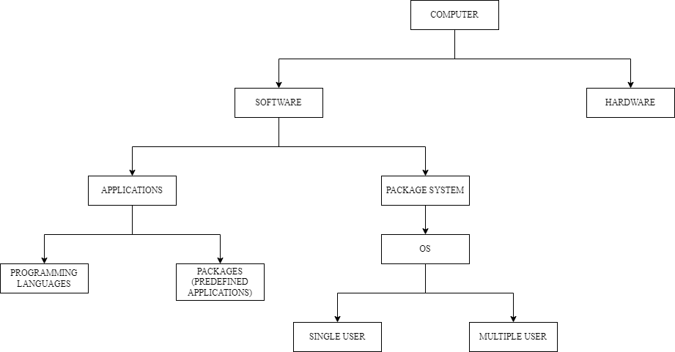

**LANGUAGES:**

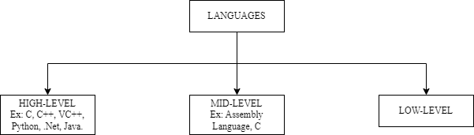

**JAVA:**

There are two types of Applications:

Standalone: Data sharing across the system is not possible. Ex: Notepad, MS-Office.

Web Based: Data is shared across the system. Servers are required. Ex: Google Sheet.

Java Features:

Why JAVA is platform independent?

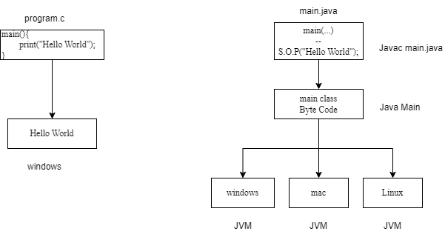

b. OOPS

c. Exception Handling

d. MultiThreading

e. Web Application

f. Open Source

g. Security

h. Supports Networking

i. Memory Management

JDK, JRE, JVM

%3CmxGraphModel%3E%3Croot%3E%3CmxCell%20id%3D%220%22%2F%3E%3CmxCell%20id%3D%221%22%20parent%3D%220%22%2F%3E%3CmxCell%20id%3D%222%22%20value%3D%22Text%22%20style%3D%22text%3Bhtml%3D1%3Balign%3Dcenter%3BverticalAlign%3Dmiddle%3BwhiteSpace%3Dwrap%3Brounded%3D0%3B%22%20vertex%3D%221%22%20parent%3D%221%22%3E%3CmxGeometry%20x%3D%22180%22%20y%3D%2210%22%20width%3D%2260%22%20height%3D%2230%22%20as%3D%22geometry%22%2F%3E%3C%2FmxCell%3E%3C%2Froot%3E%3C%2FmxGraphModel%3E

JDK

Javac

Java

Java doc

Libraries

Compiled Class Files

JVM

Arithmetic Operators:

Add()

Sub()

Mul()

Divide()

Modulo, remainder()

Basic JAVA Programming

Largest of two numbers

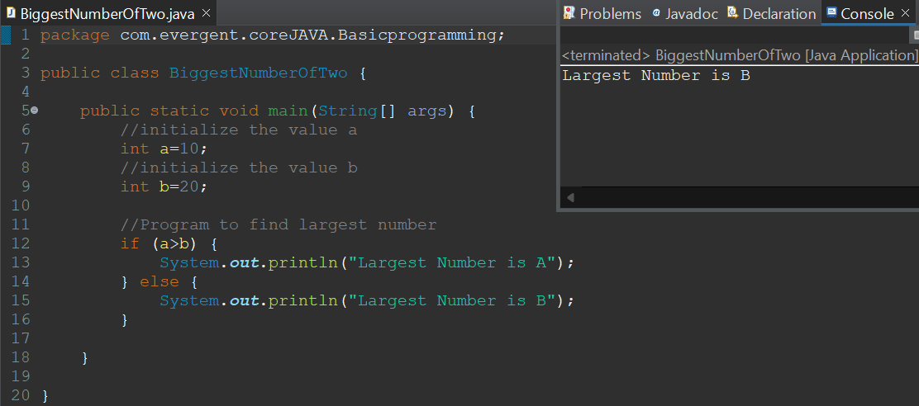

Largest of three numbers

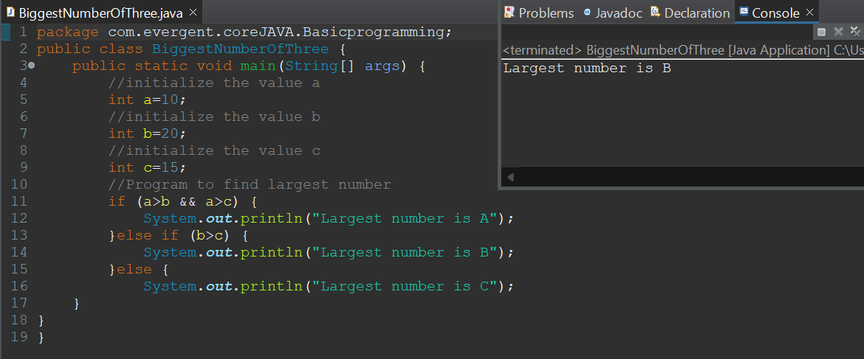

Swapping of two numbers using temp variable and without using temp variable

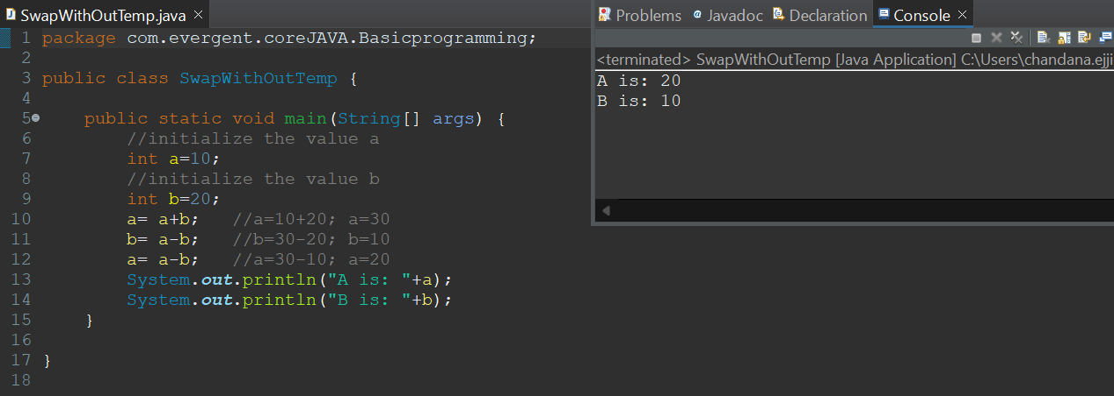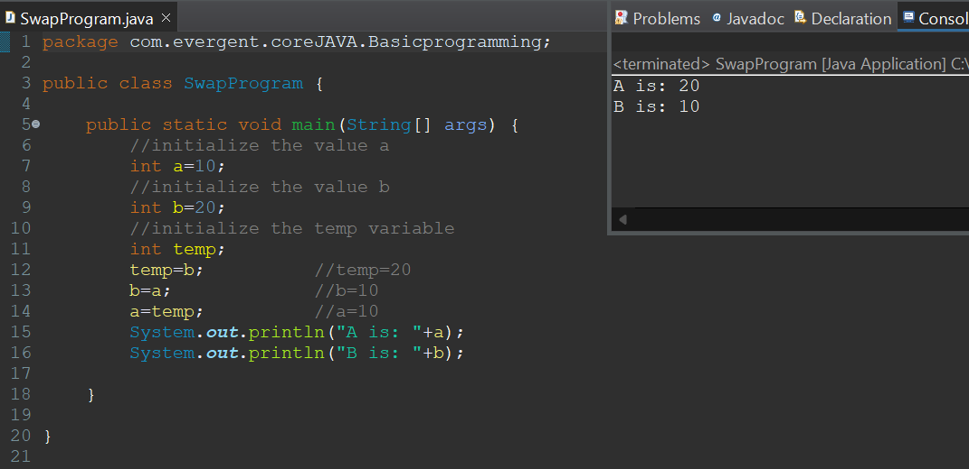

d. Largest of 5 numbers

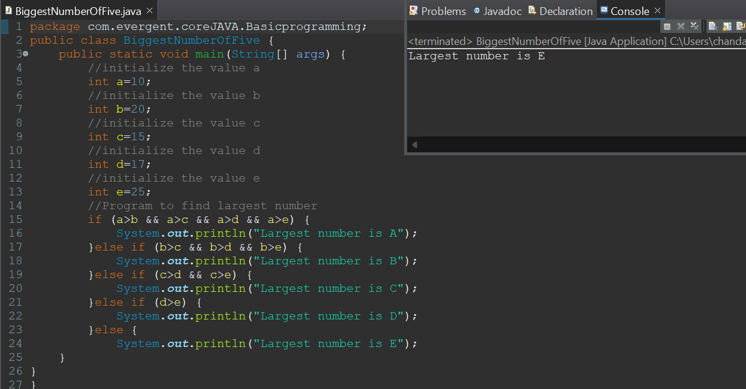

Packages are of two types: a)Predefined b)Userdefined

Predefined packages: java.lang- default package

java.io- I/p, o/p packagae

java.util- collection package

java.sql- JDBC package

Write a program to find Factorial of a Number

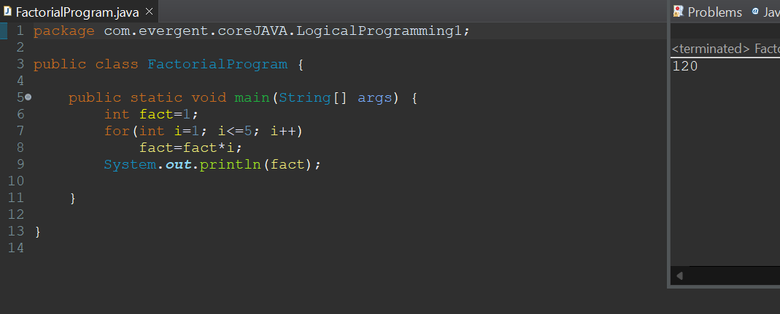

Write a program to find Fibonacci series

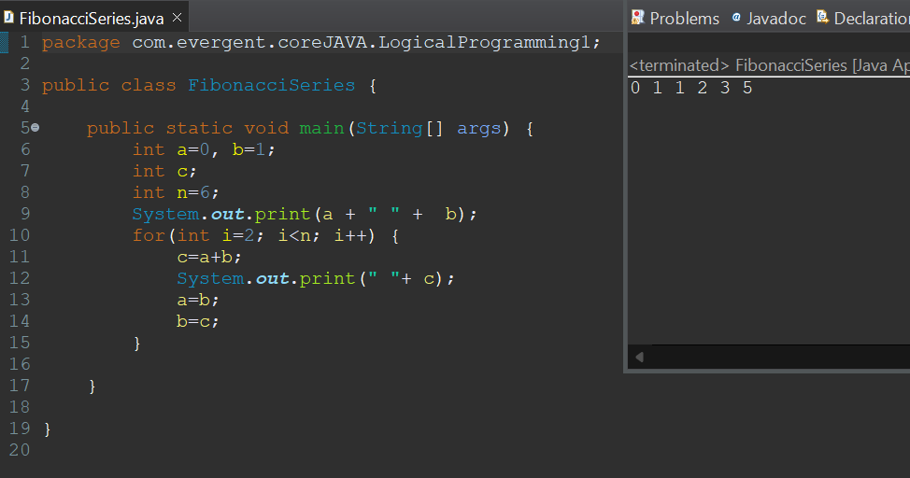

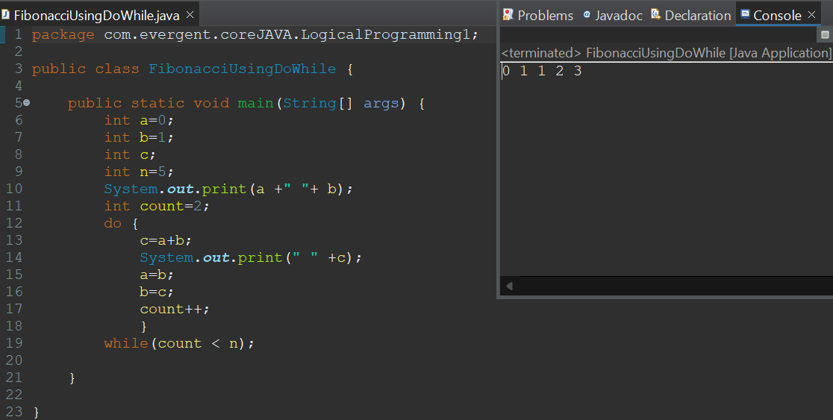

Nested Loops: A loop statement within the another loop statement (for loop)

Array: Homogeneous elements

1. One Dimensional:

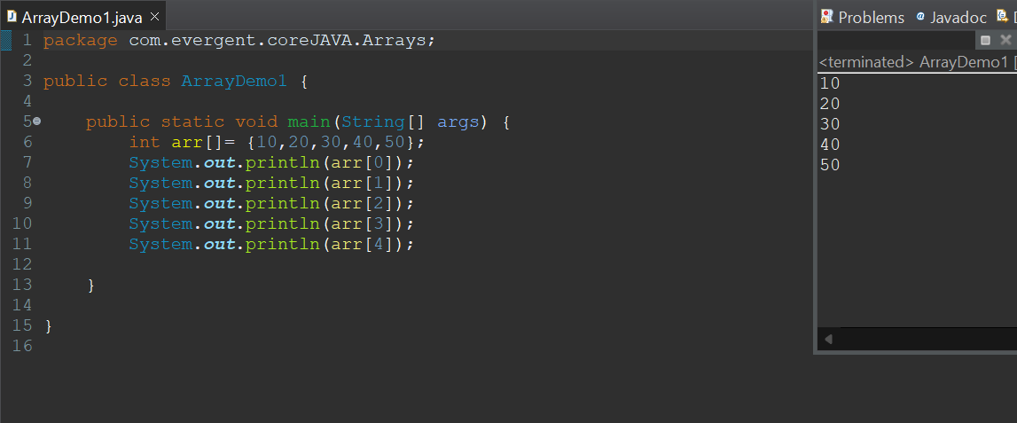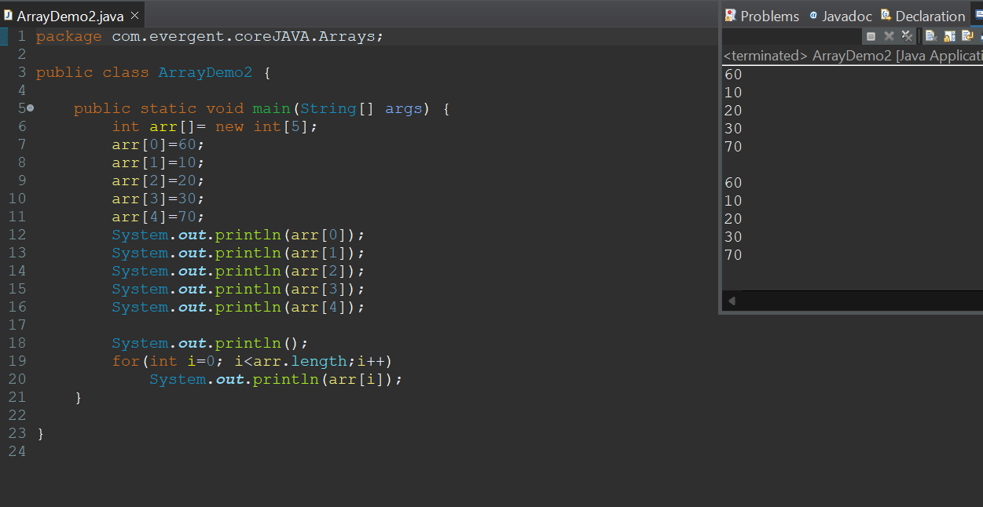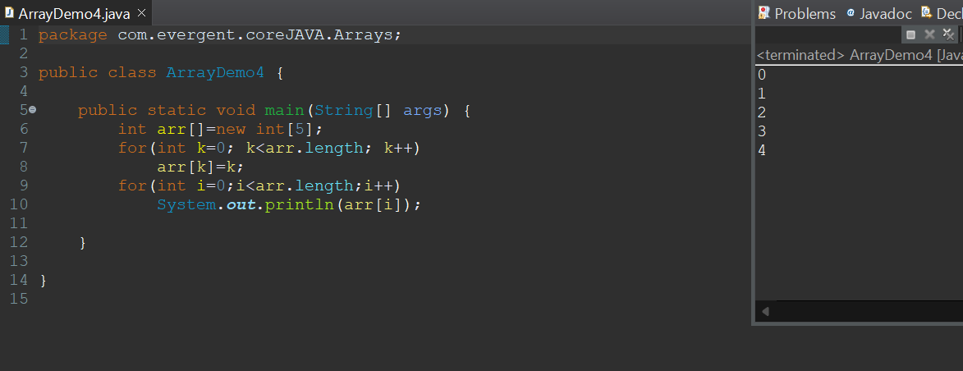

1. Two Dimensional

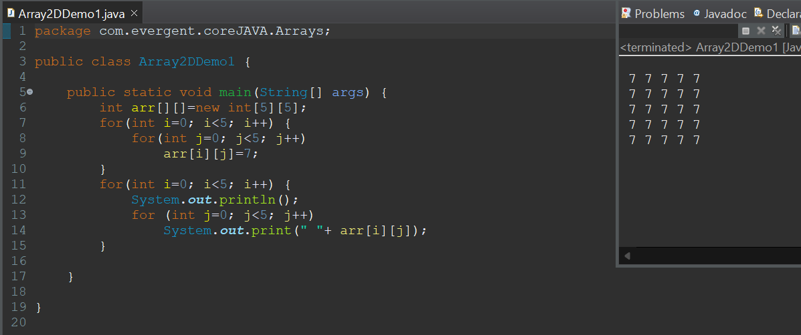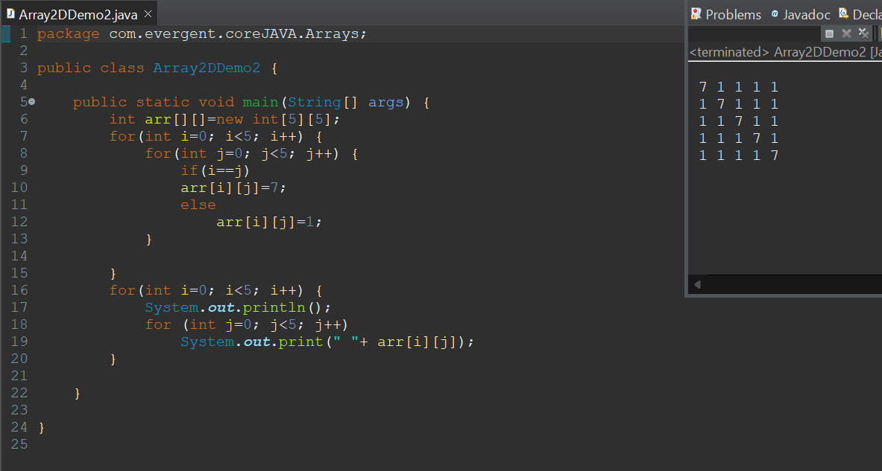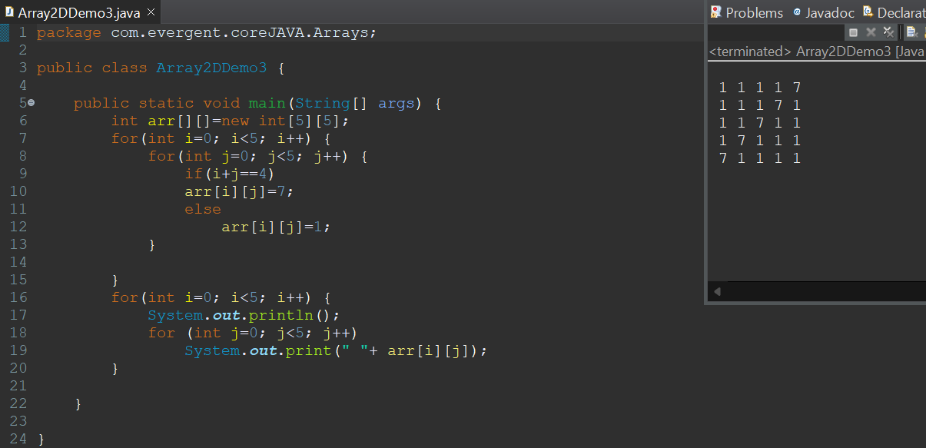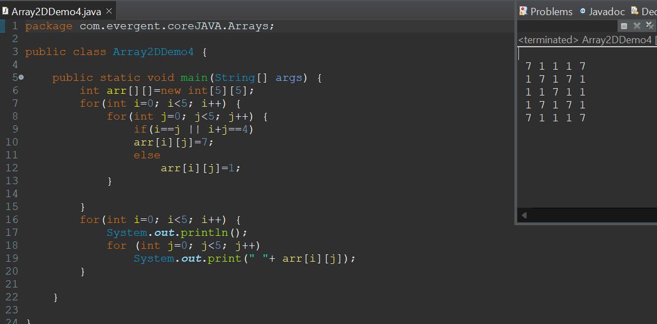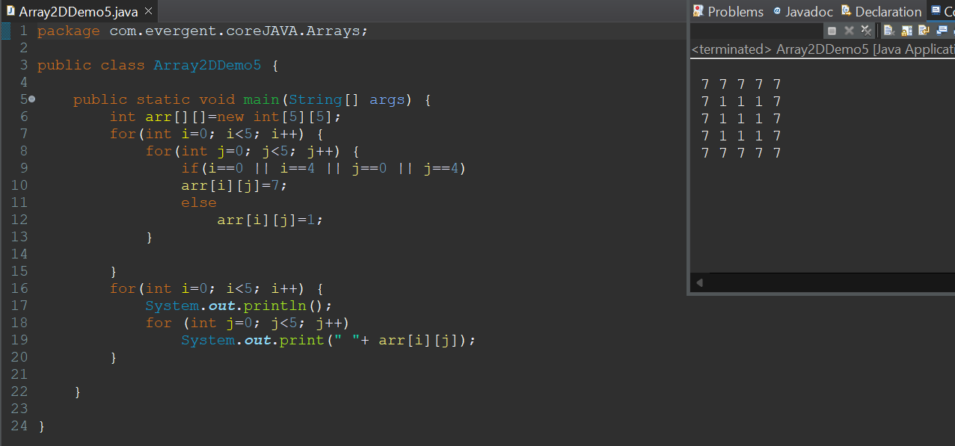

Logical Programming: Fibonacci series and Factorial

Switch Case: Switch statement in java is a muti-way branch statement

Java Lang: Default package

Object Class Method: Super class for all classes in Java.

Scanner Class: Scanner Class in java is used to take the input values from the keyboard

Enum: enum is a special class that represents the group of constant

Pattern programs:

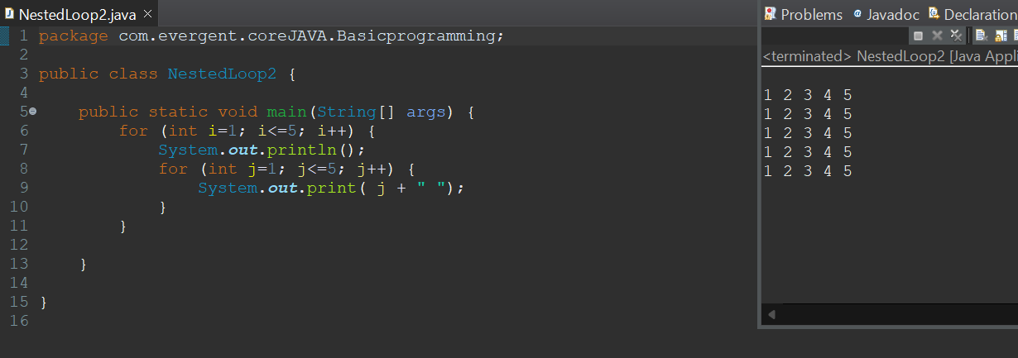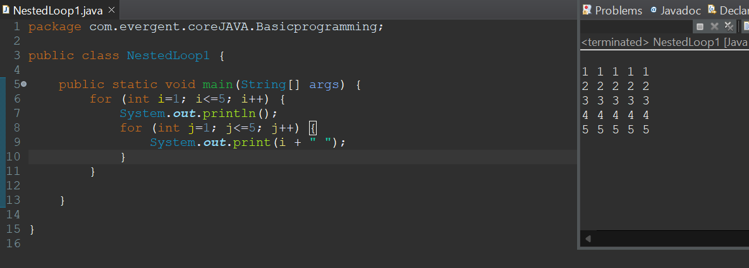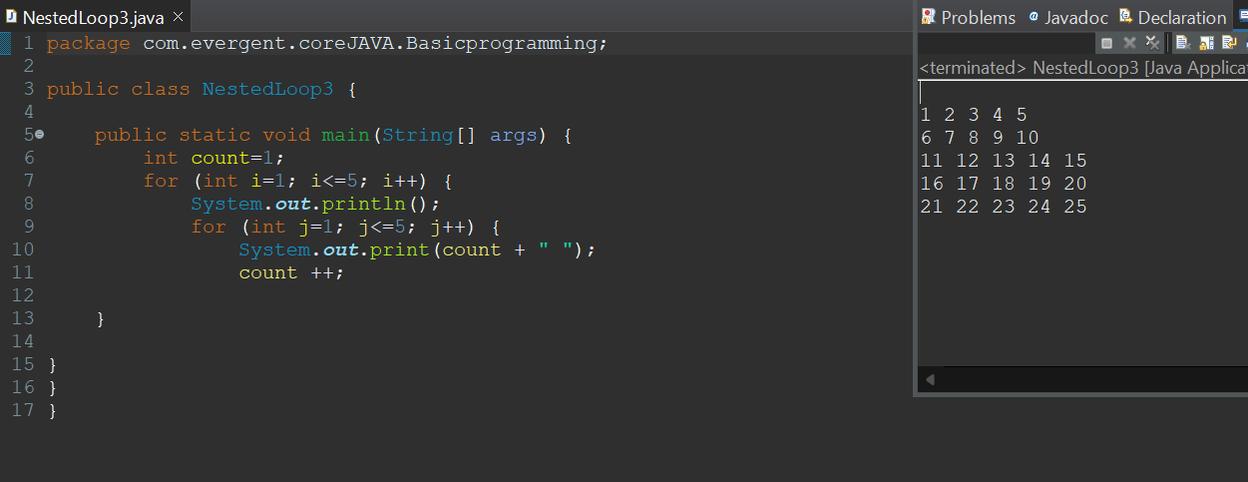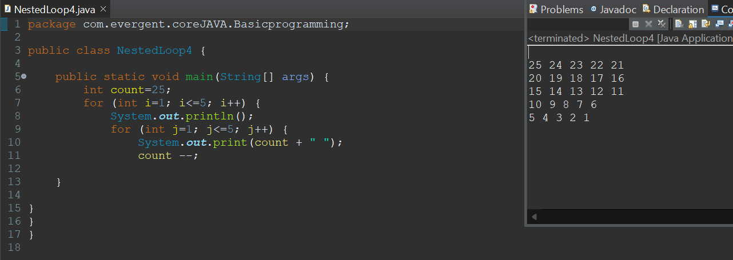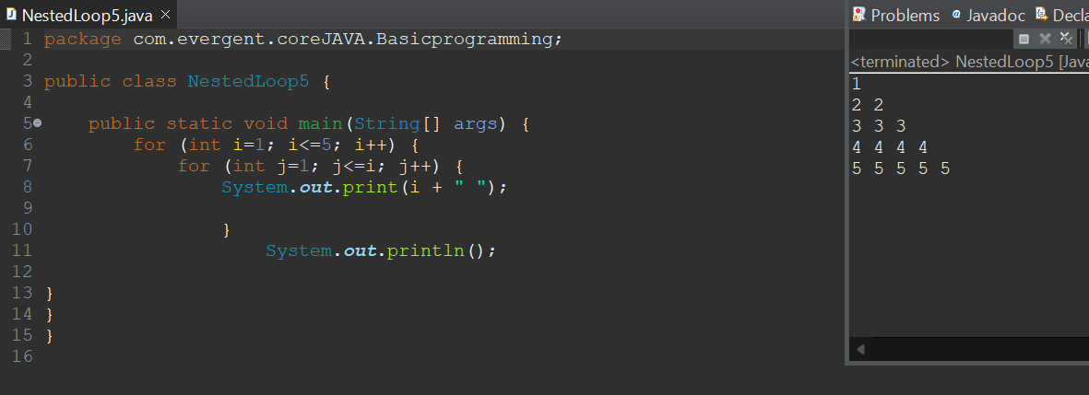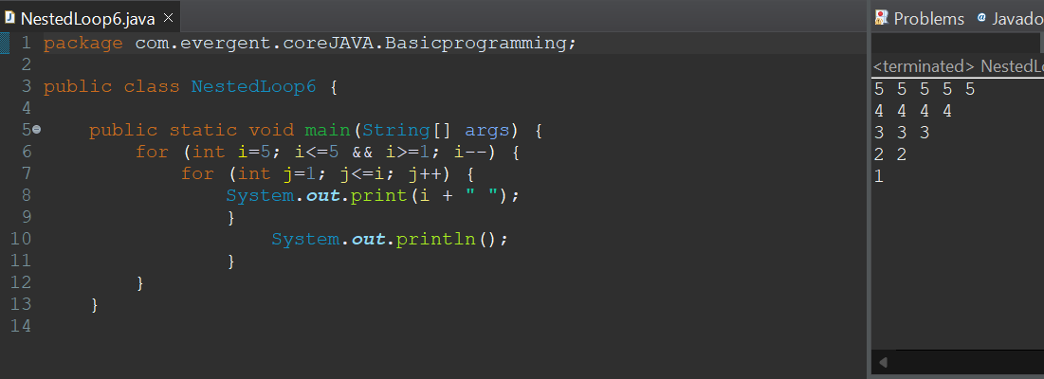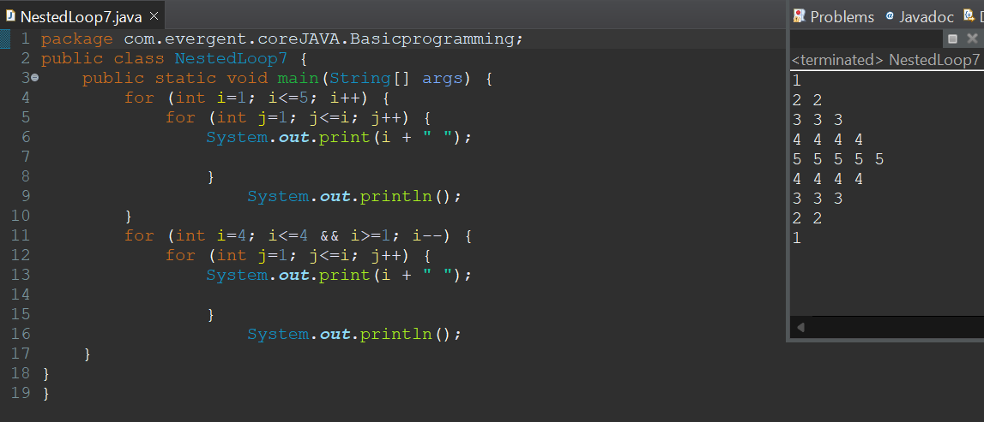

OOPS: Object Oriented Programming is a concept.

Encapsulation: mechanism of binding attribute and methods together inside class and object creation.

Example problems:

1. Calculation:

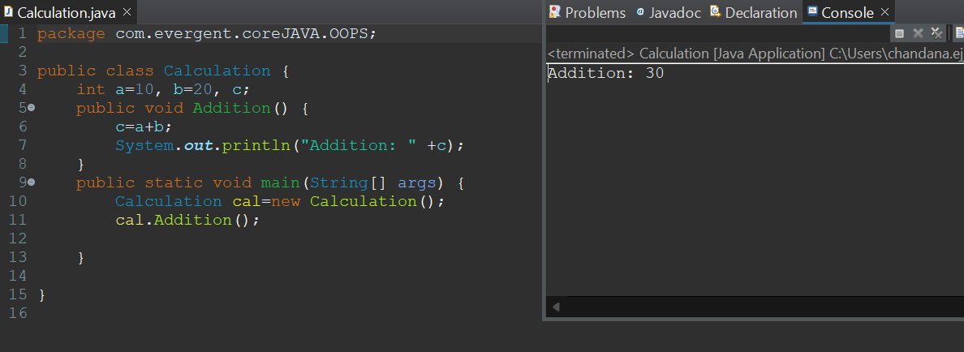

1. Person Class

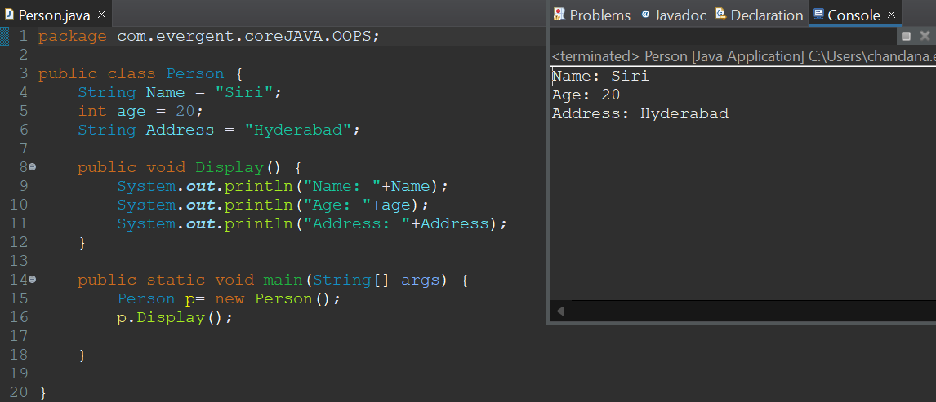

1. MethodFlow Class

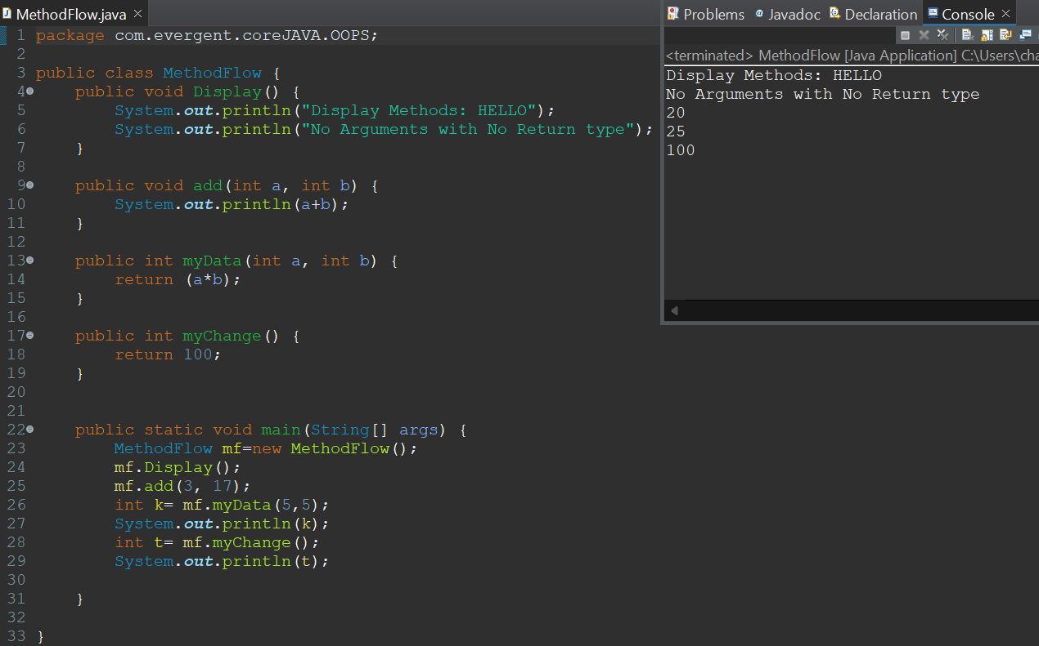

Inheritance: re-usability of functions from super class to sub class

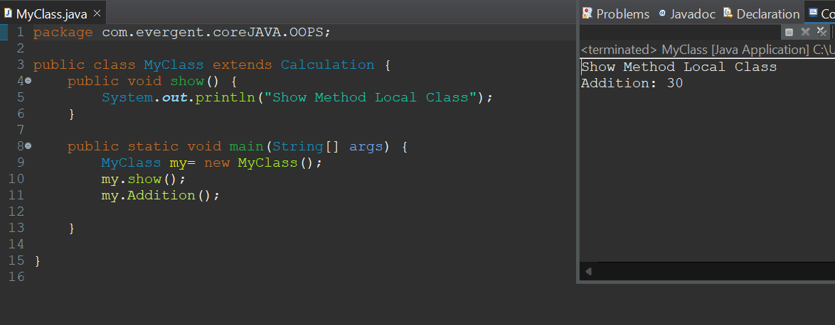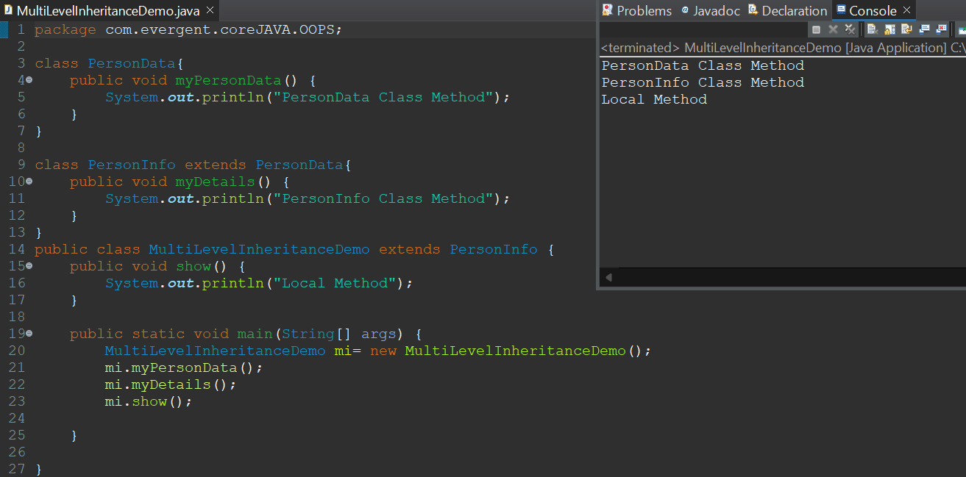

Polymorphism:

1. Overloading (Compile Time Polymorphism)

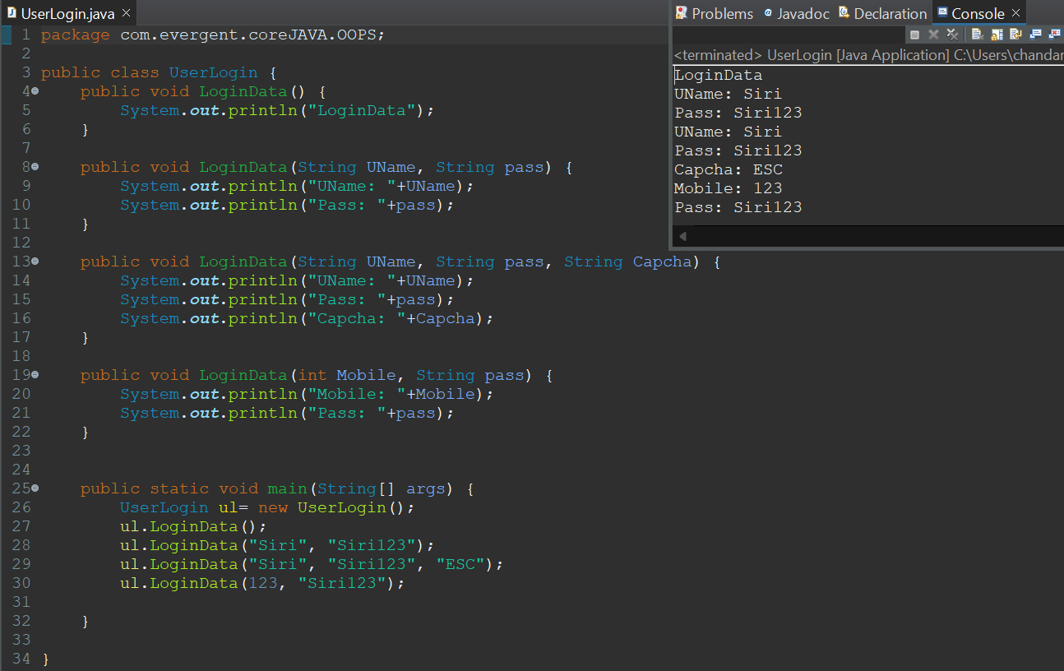

1. Overriding (RunTime Polymorphism)

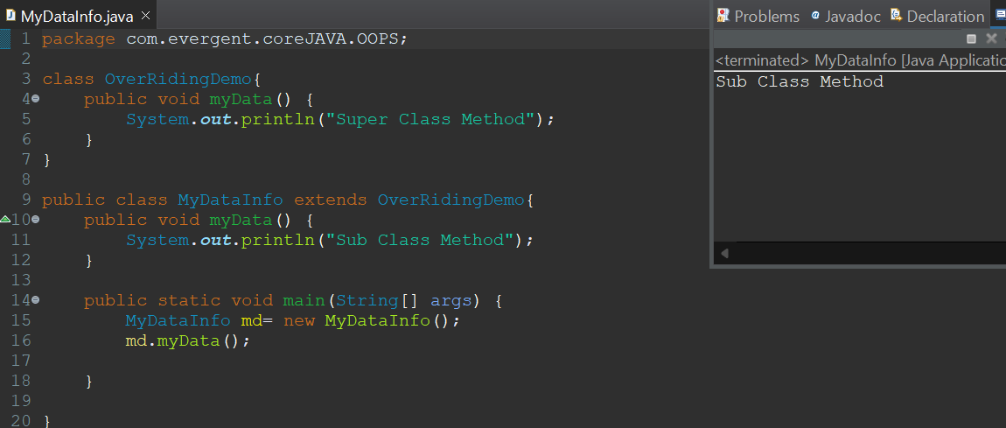

Abstraction: hiding of complex details, showing only essential features.

IS_A : Through Inheritance

HAS_A: Through object creation

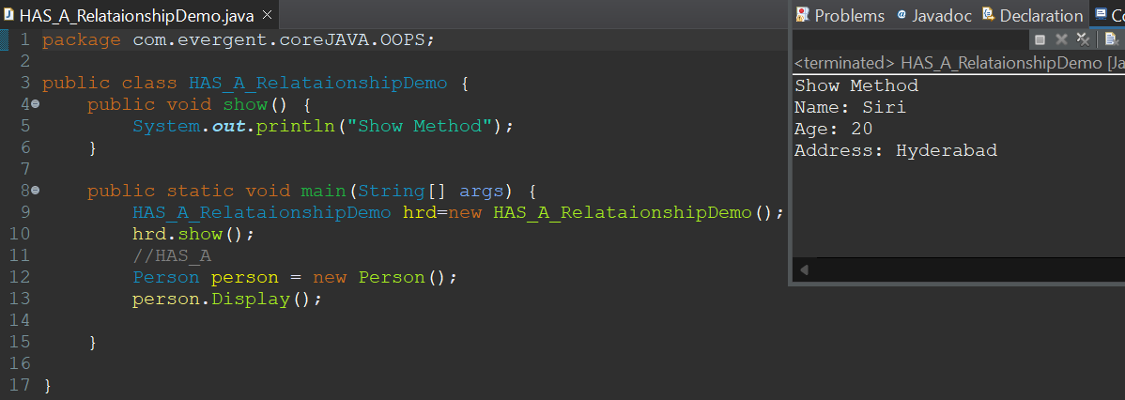

**Constructors:**

1.Class Name and constructor Name should be same.

2.There are two types of Constructors:

I) Default Constructor

II) Parameterized Constructor

3.We can access constructor while creation of objects.

4.Constructors are mainly for initialization.

5.Constructors doesn’t have any return type. Not even void also.If we declare as void, the compiler will consider that as method not as constructor.

6.Every class needs at least one default constructor.

7.This: This is a keyword, always pointing to instance variable.

8.Super: invokes methods, constructors of super class from subclass

9.Always constructors are overloaded.

10.Copy Constructors: creates a new object as a copy of an existing object duplicating its value.

* Write a program to understand Default and Parameterized constructor(using THIS keyword and without THIS Keyword)

//Default Constructor:

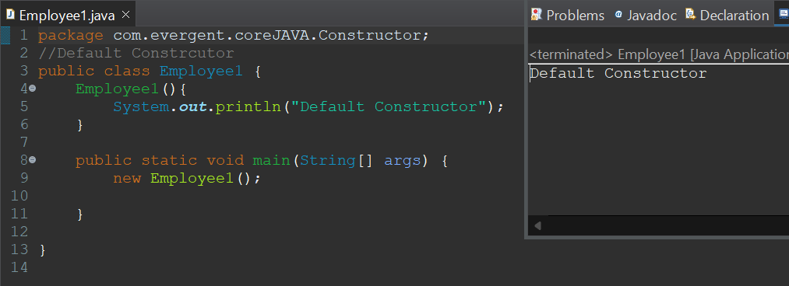

//Parameterized Constructor:

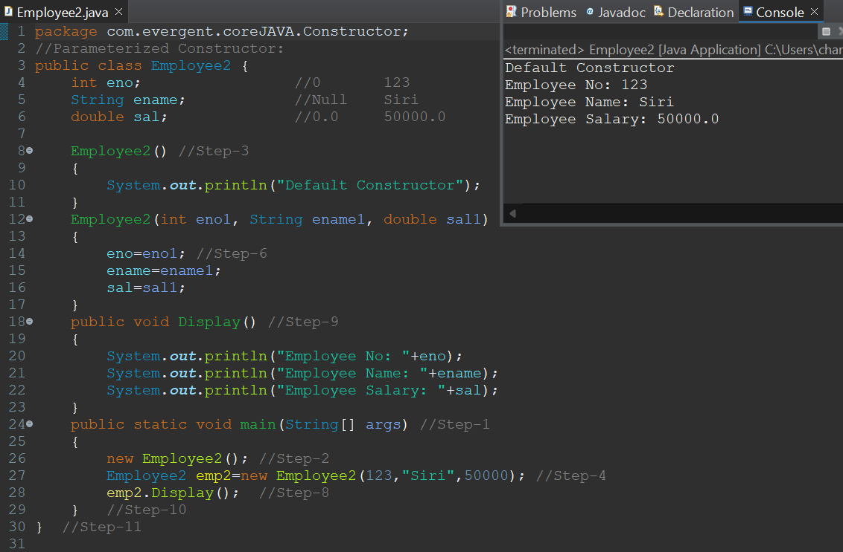

//Parameterized Constructor using THIS keyword:

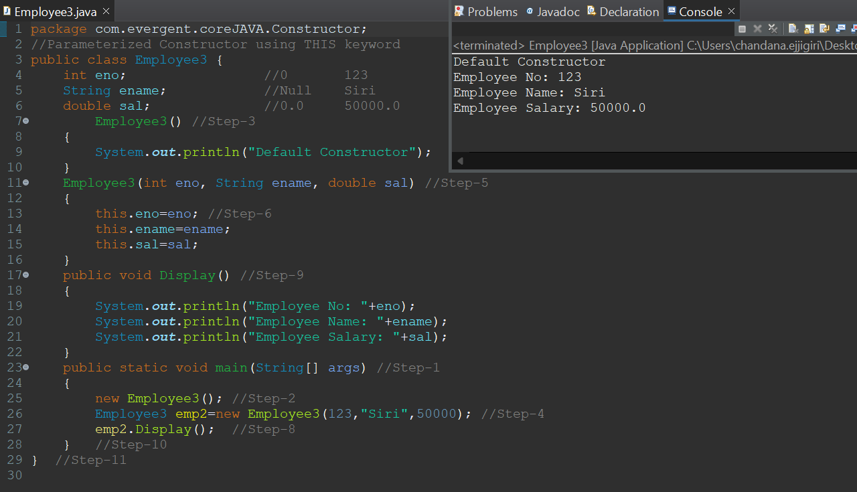

* Write a program showing that Constructor doesn’t have any return type.

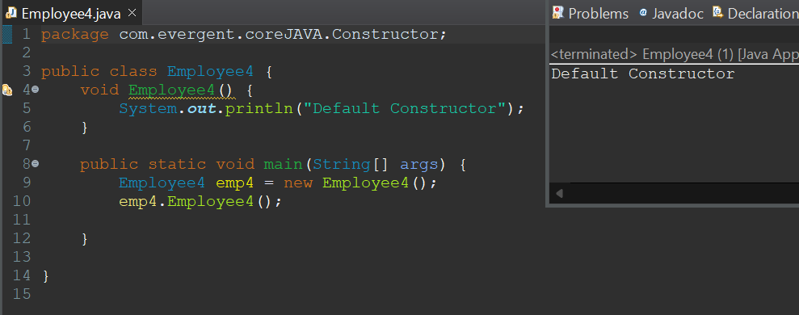

* Write a program to show that THIS keyword is used to call one constructor to another constructor (within a class).

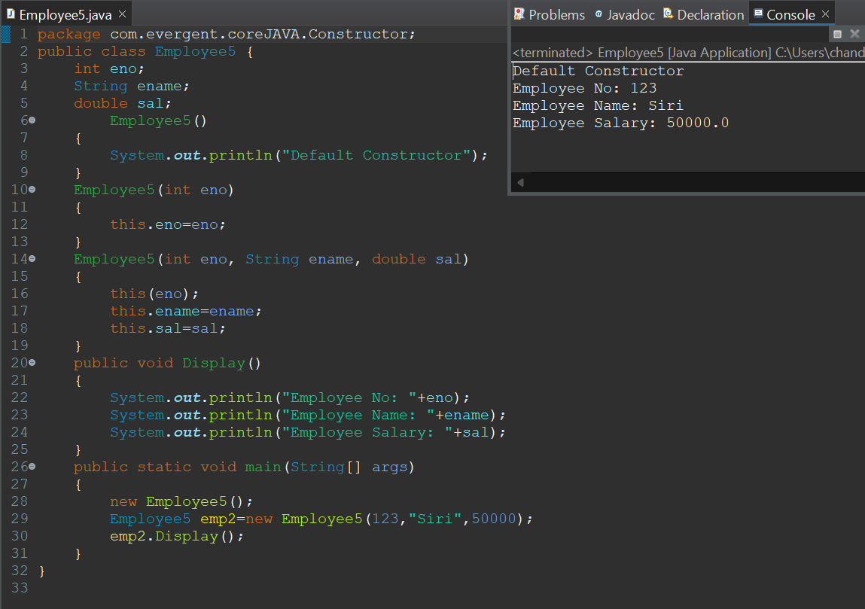

* Write a program to understand SUPER keyword.

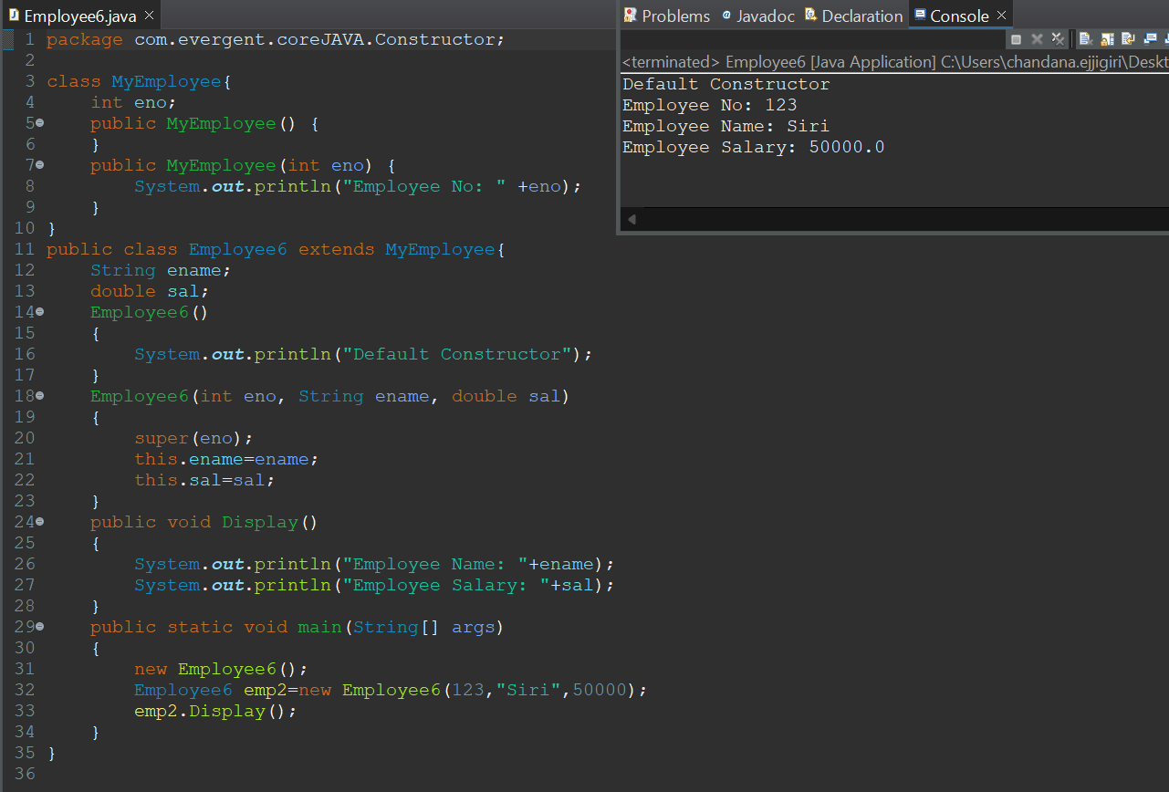

* Write a program to understand THIS keyword.

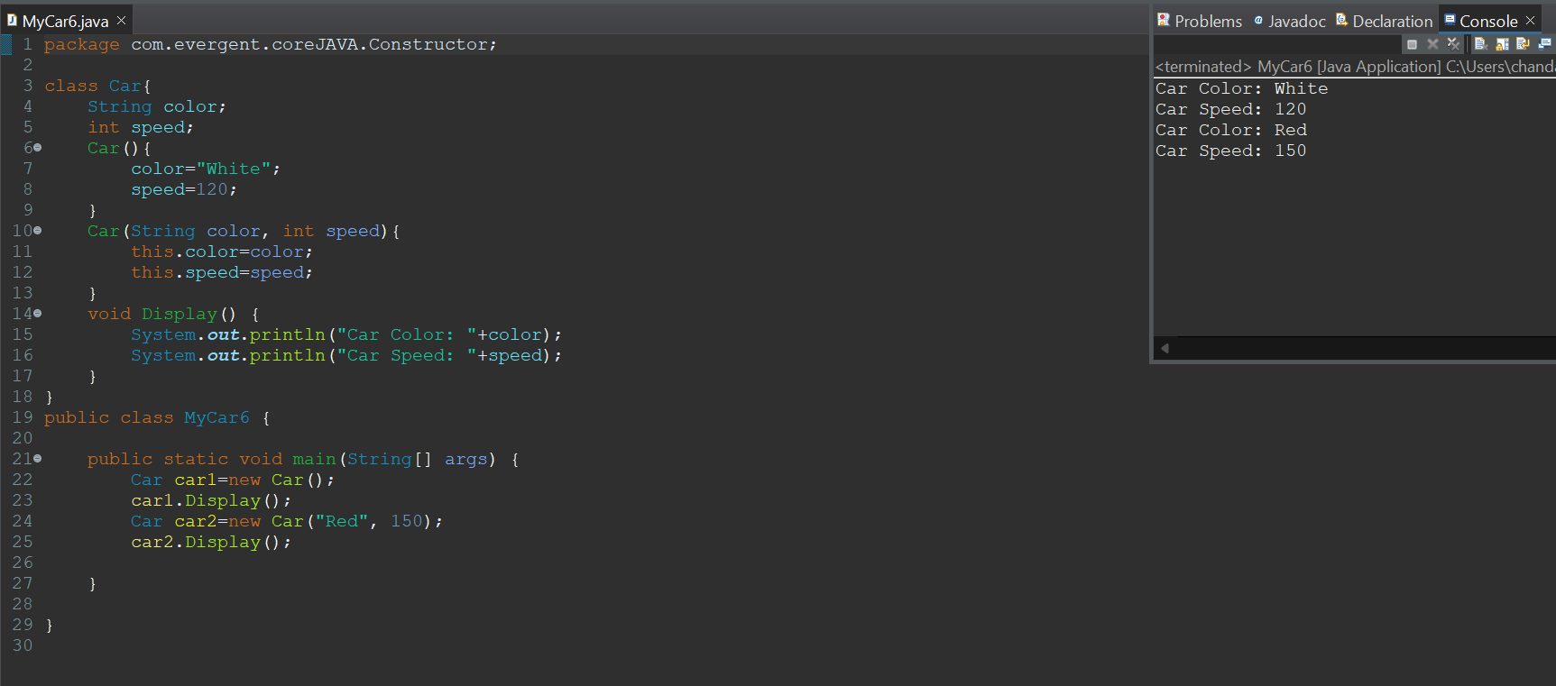

* Write a program including Inheritance, SUPER, THIS keywords.

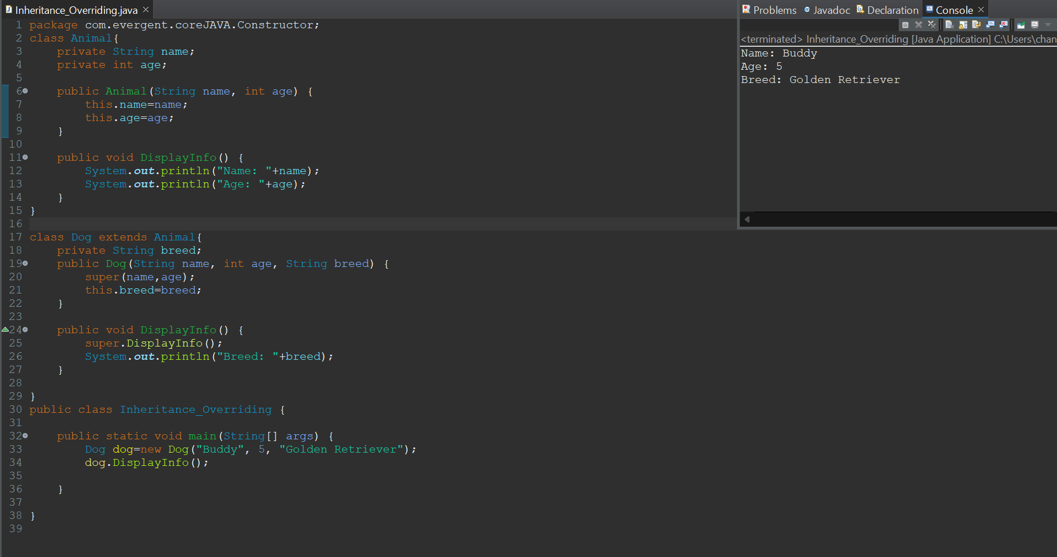

* Write a program to understand Copy Constructor.

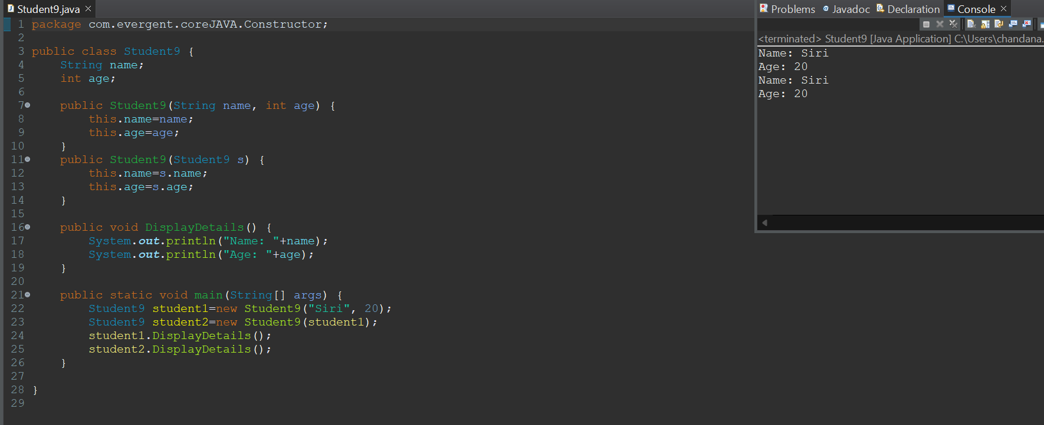

**Static:**

1. Static is a keyword.
2. We can declare static as variables and methods
3. We can access static variables and methods direct through classname.methodname and classname.variablename.
4. Static methods can access static variables and static methods
5. Static methods cannot access non-static variables and static methods
6. Non-static methods can access static variables and static methods
7. Static Blocks- Once a class is loaded into the JVM, static blocks are initiated first.
8. If a static variable is modified, then it will reflected globally

#Write a program to understand the STATIC keyword.

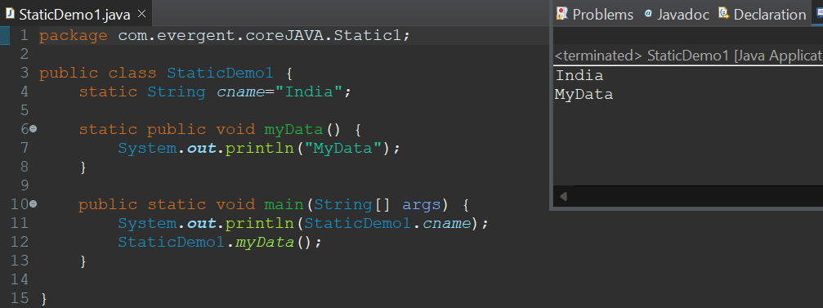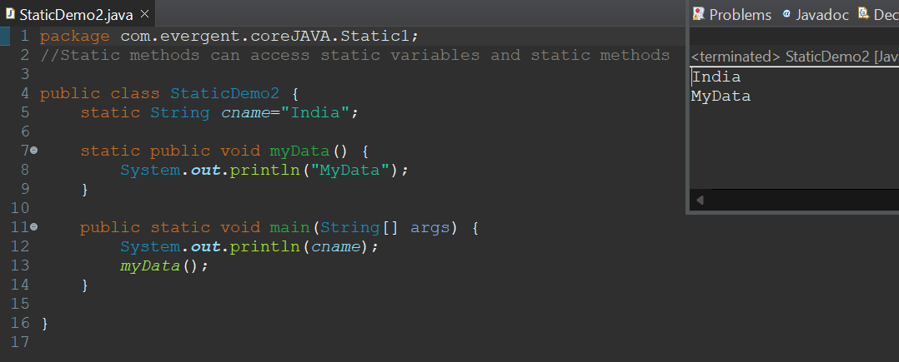

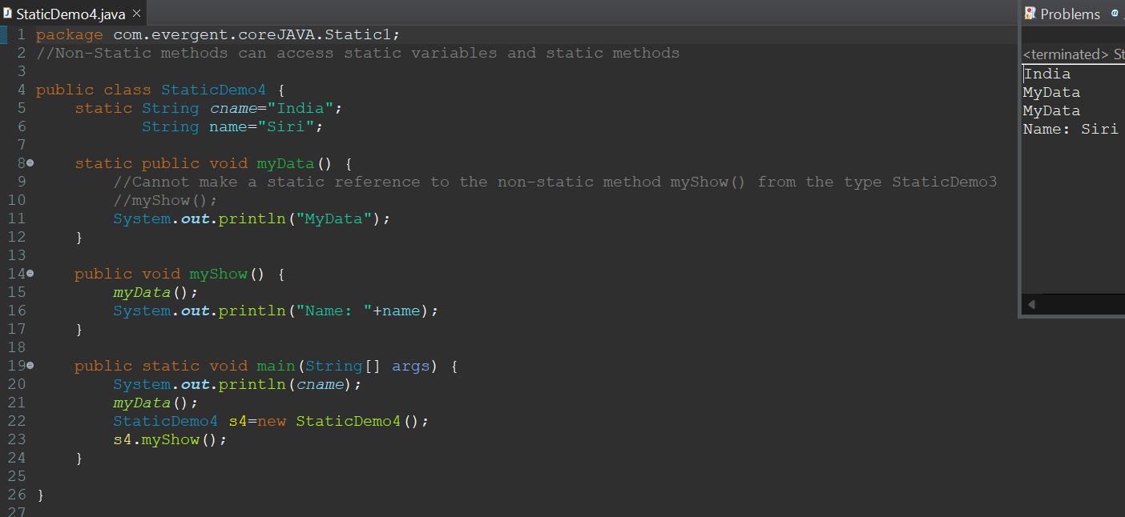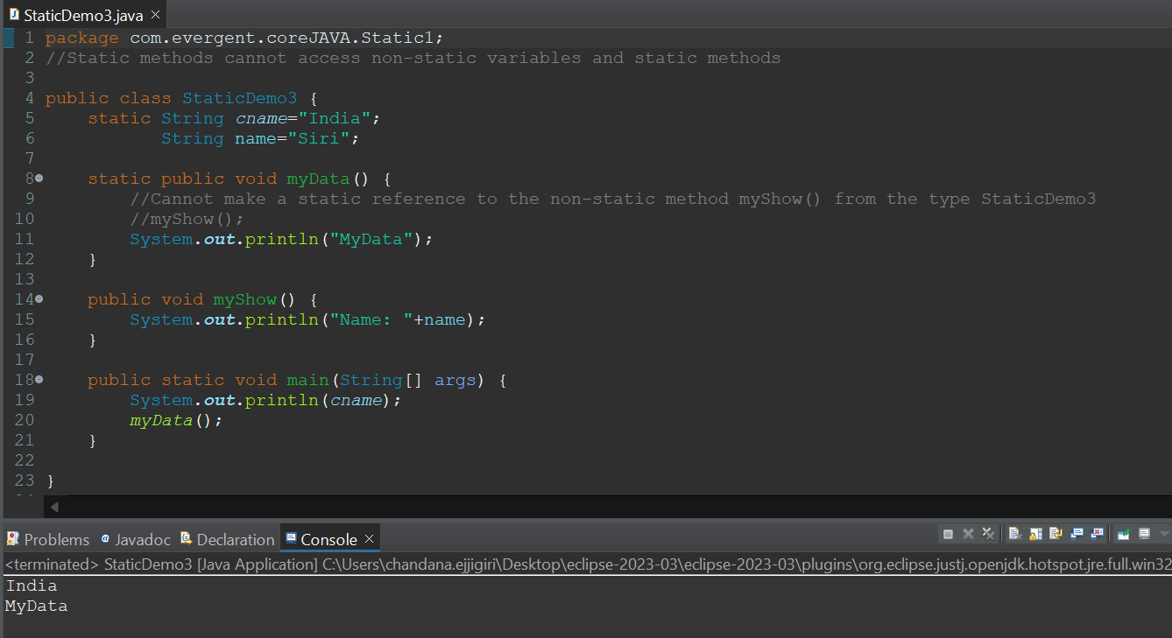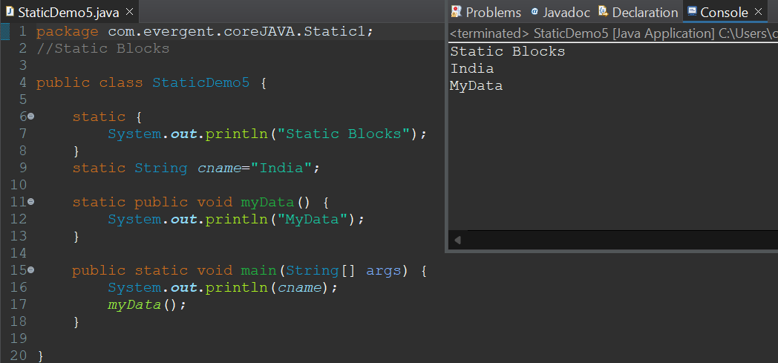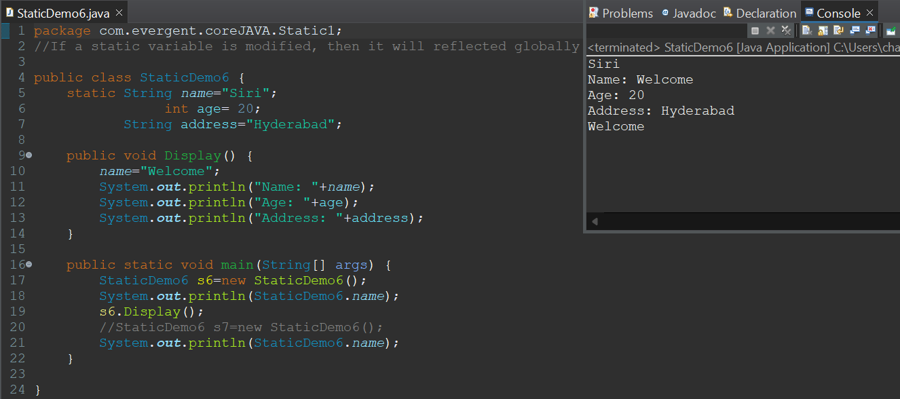

**Final:**

1. Final is a keyword.
2. We can declare final as variables, methods, classes.
3. Final variable can't be modified.
4. Final methods can't be override
5. Final class can't be extended(Inheritance)

#Write a program to understand the FINAL keyword.

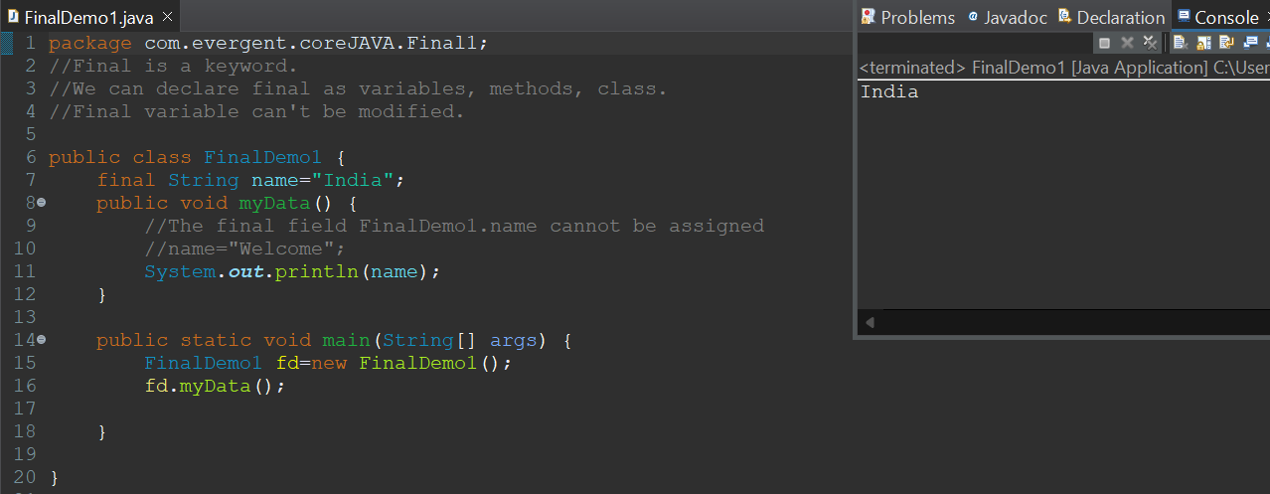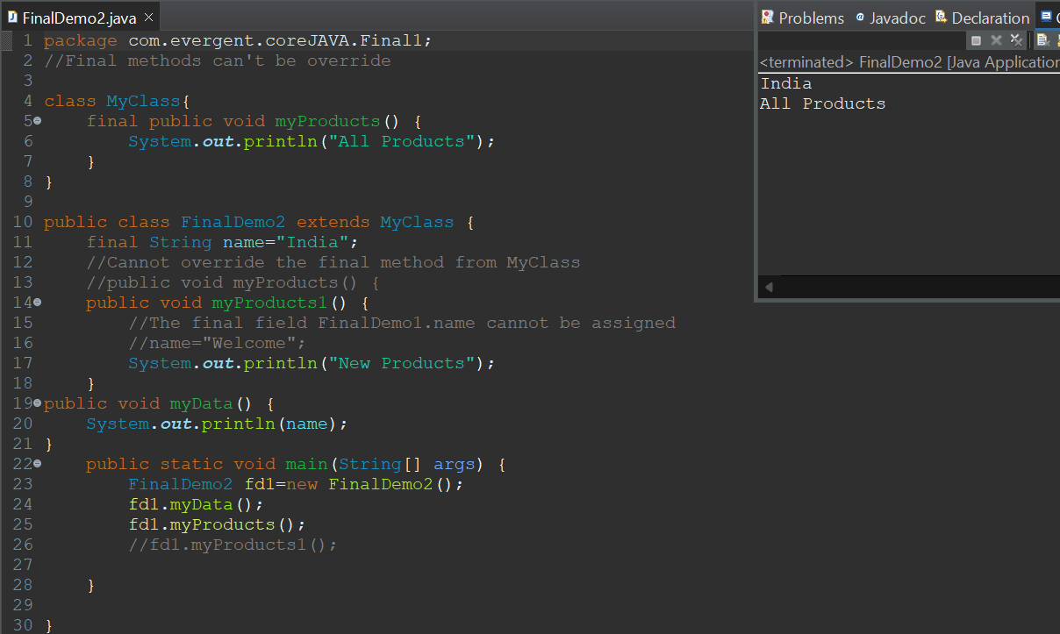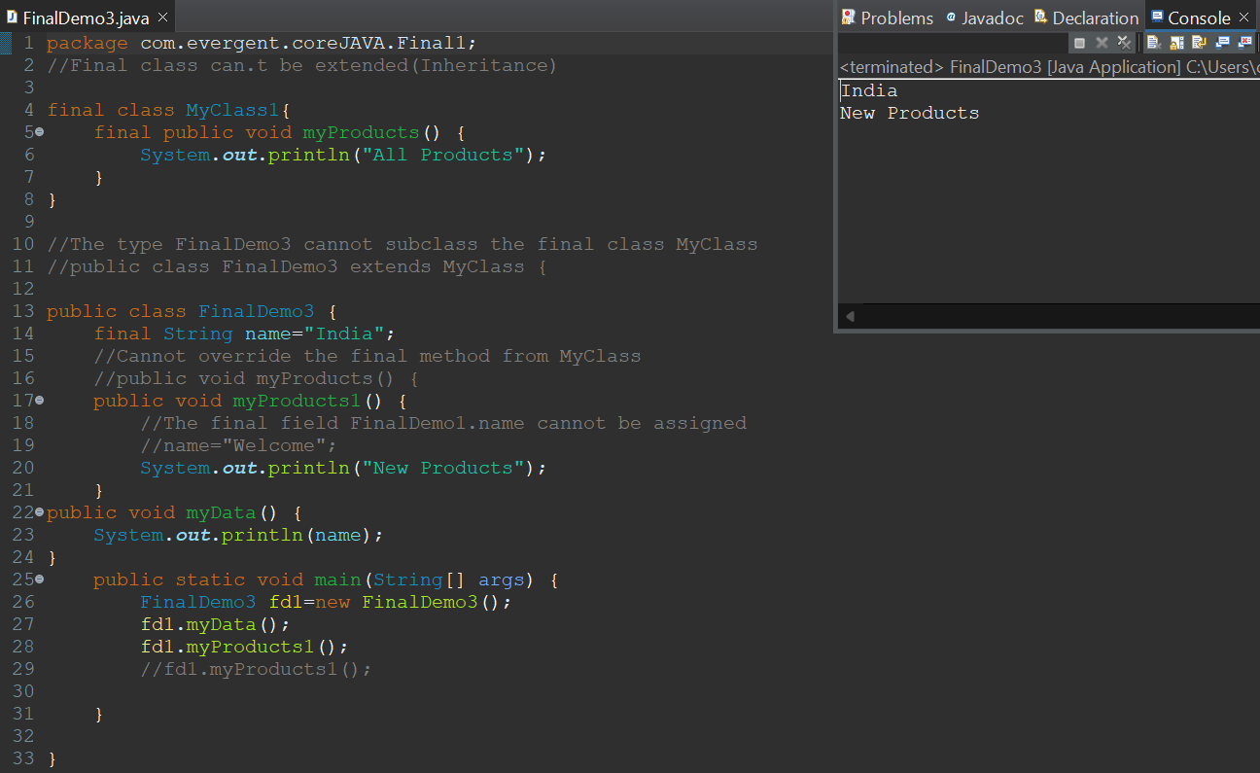

**String:**

**1.1 String class**

1. String is Final Class
2. Strings are immutable
3. -Why strings are immutable?
4. Once we declare any string object, it is constant. If we are trying to modify an existing string it will create another memory location, the existing object is eligible for Garbage Collection.
5. String class having methods
6. All string class methods are non-synchronized

**1.2 StringBuffer**

1. String is Final Class
2. StringBuffer is mutable
3. StringBuffer having methods
4. All StringBuffer methods are synchronized
5. StringBuffer is not recommended to use for development but is still in the API

**1.3 String Builder**

1. String is Final Class
2. StringBuilder is mutable
3. String Builder having methods
4. All String Builder methods are non-synchronized

**String Class:**

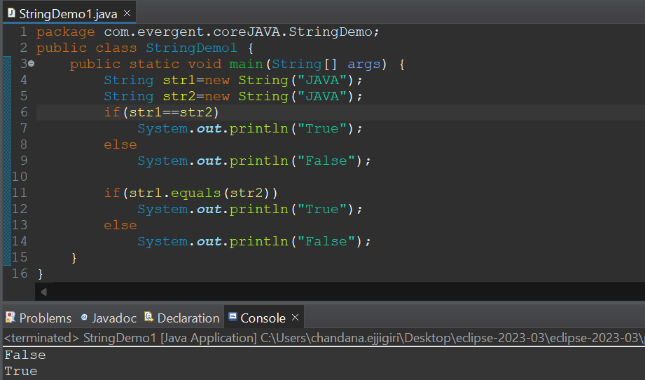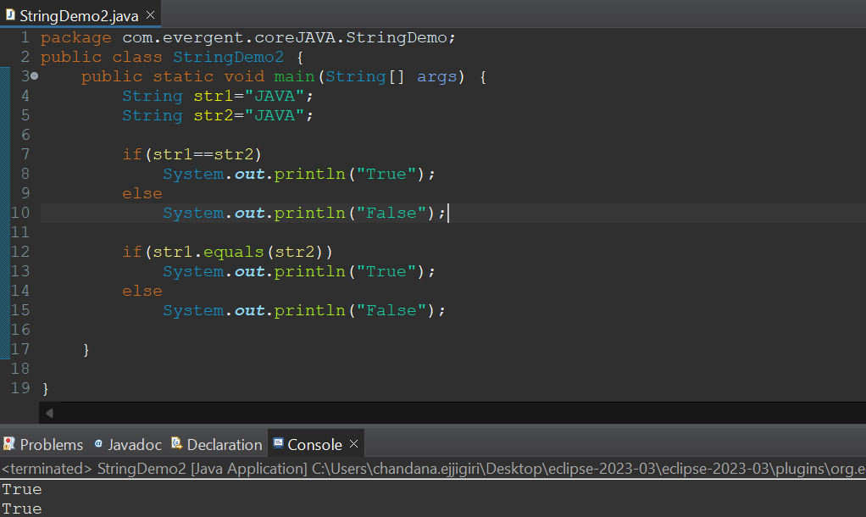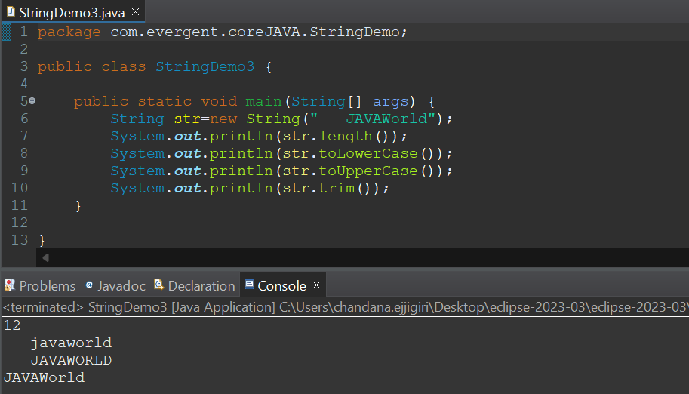

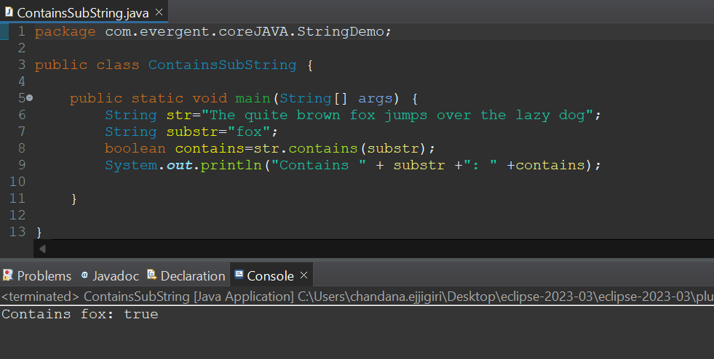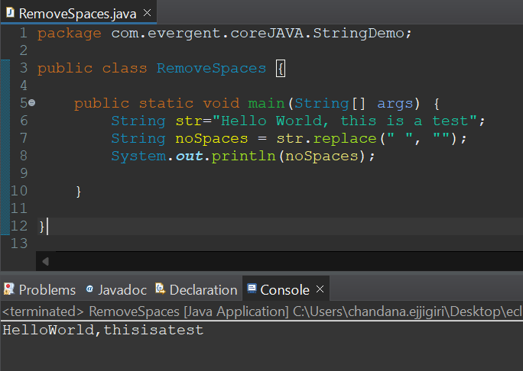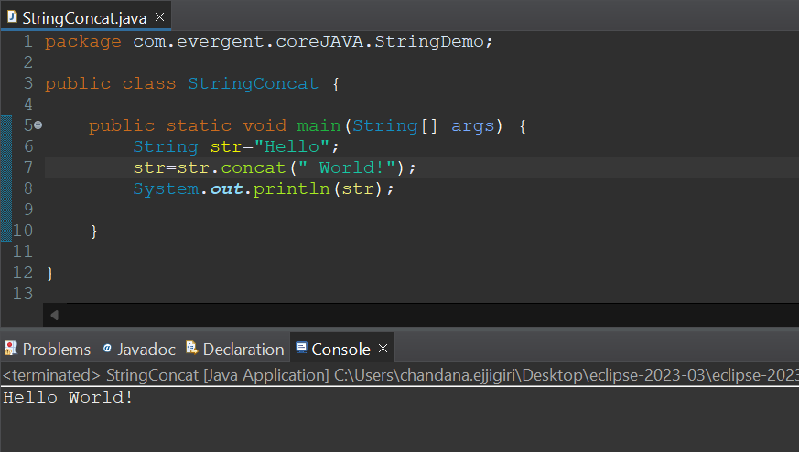

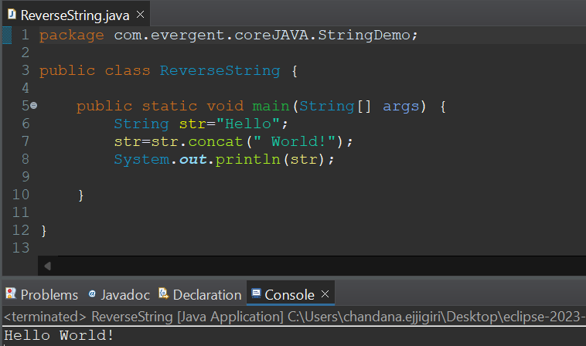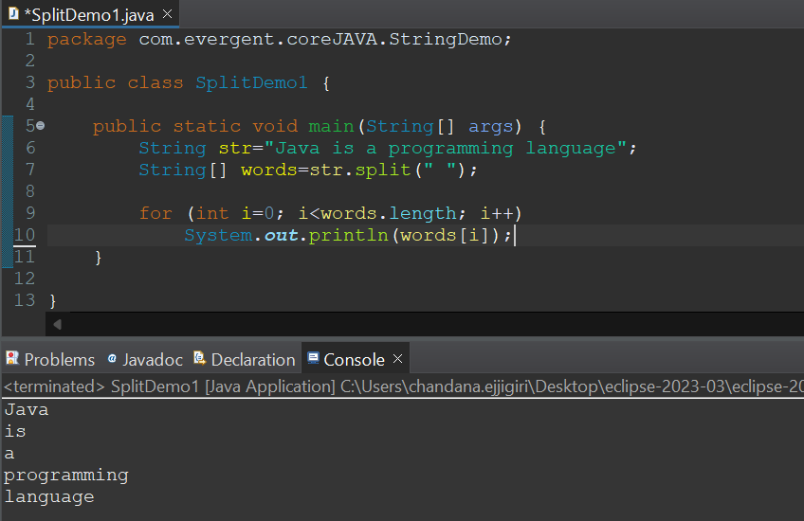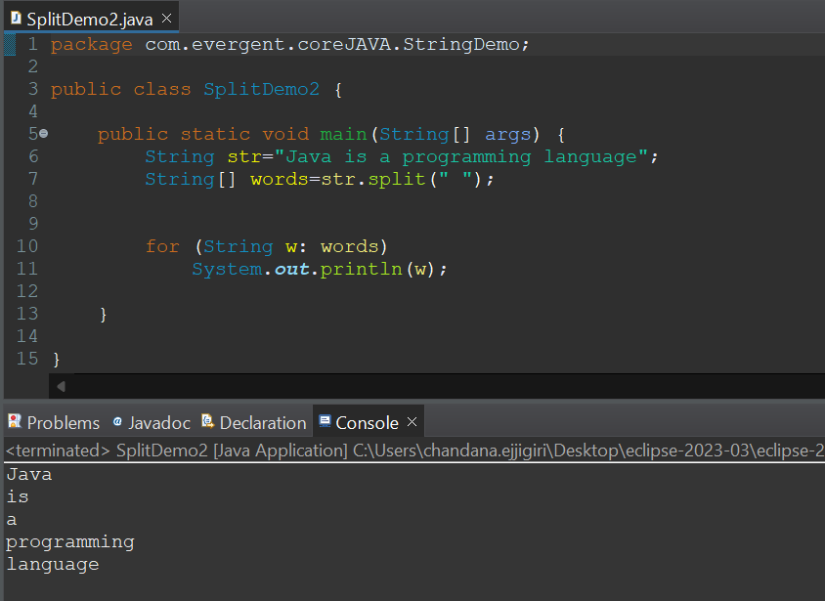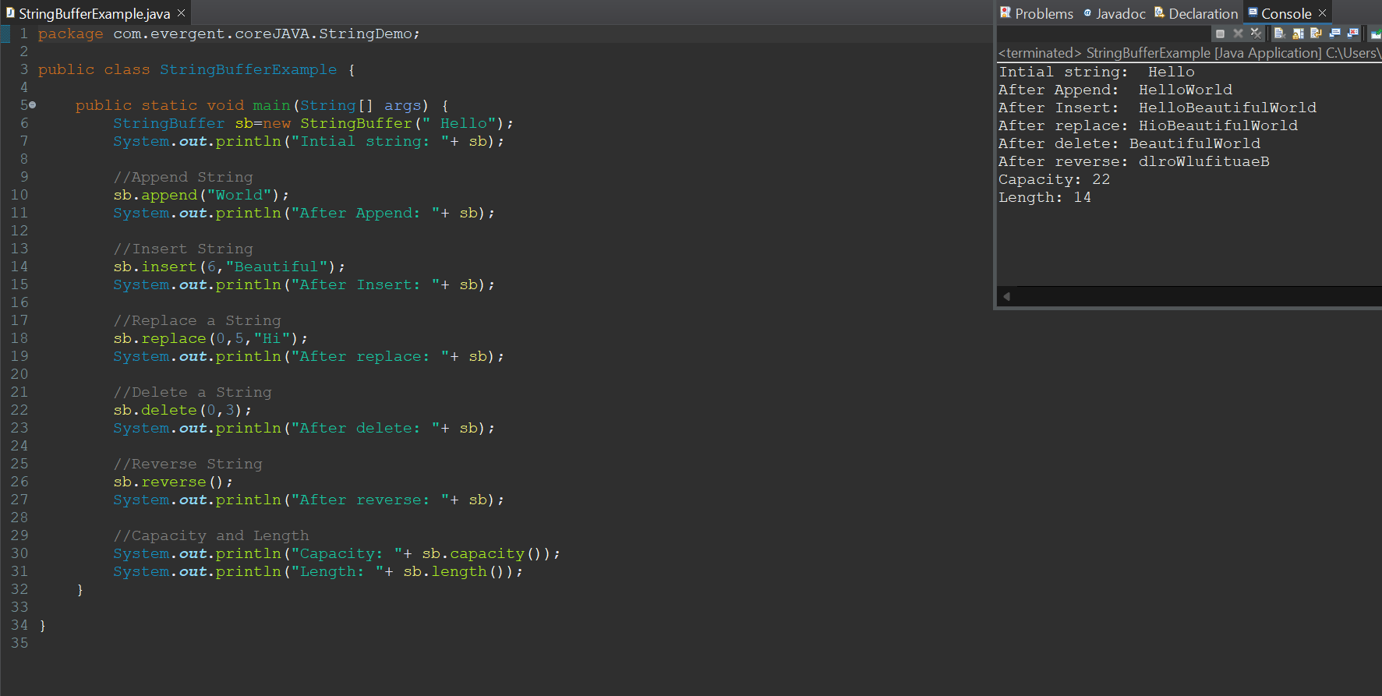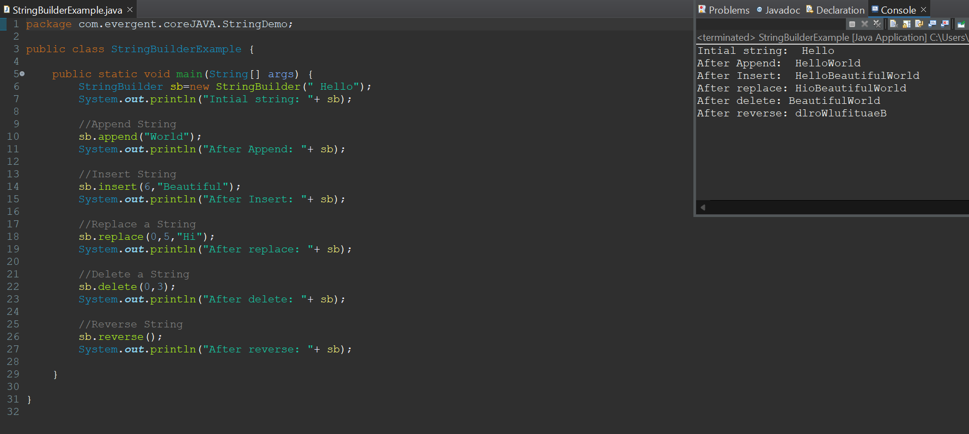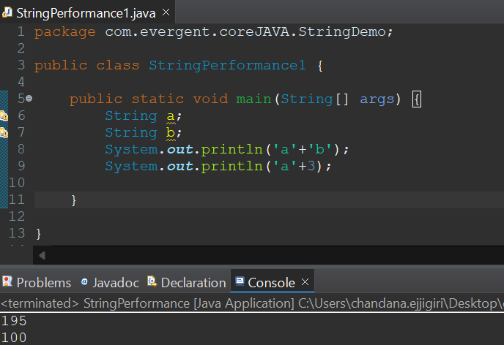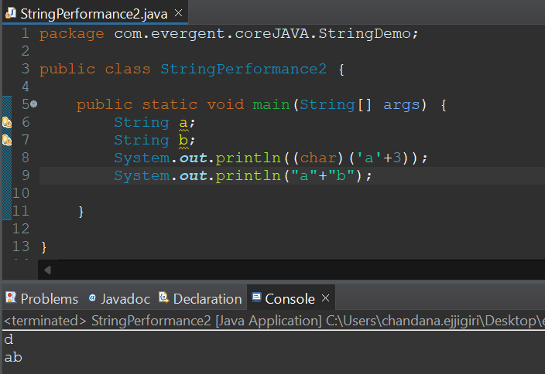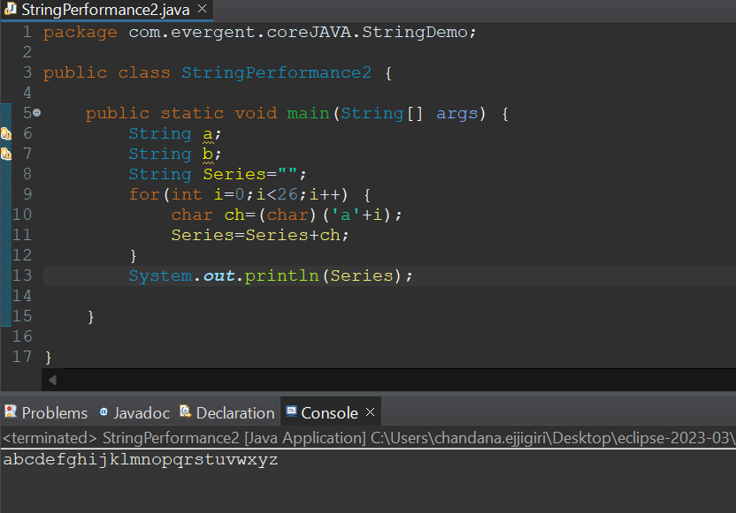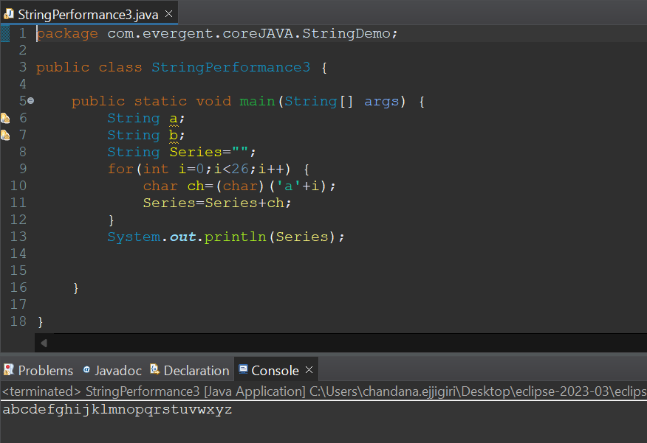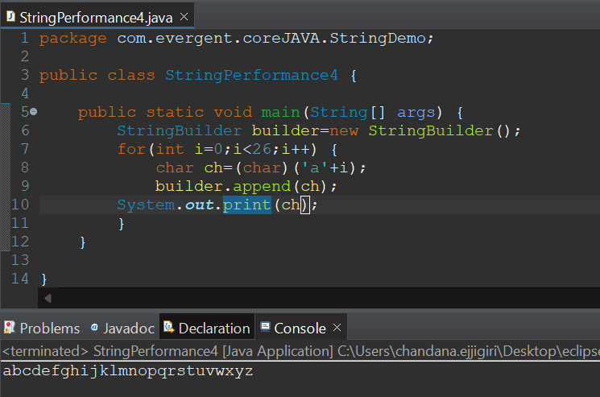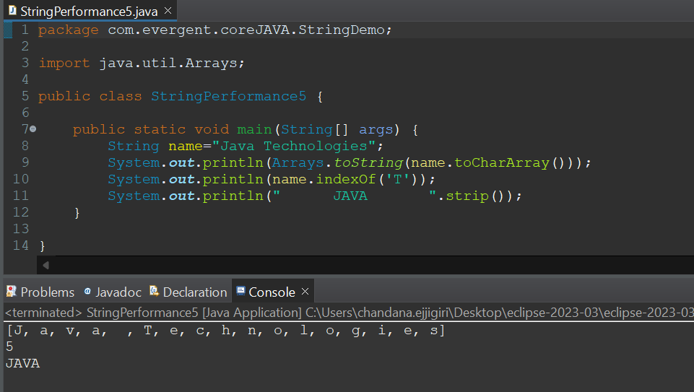

**We can create our own immutable class?**

1. We can declare class as final.
2. The class is declared as final so that it cannot be sub classed.
3. Private final fields:

* The fields name and age are private and final constructor.

1. Constructor:

* The constructor initializes the final fields when the person object is created.

1. Write a program to create immutable strings.

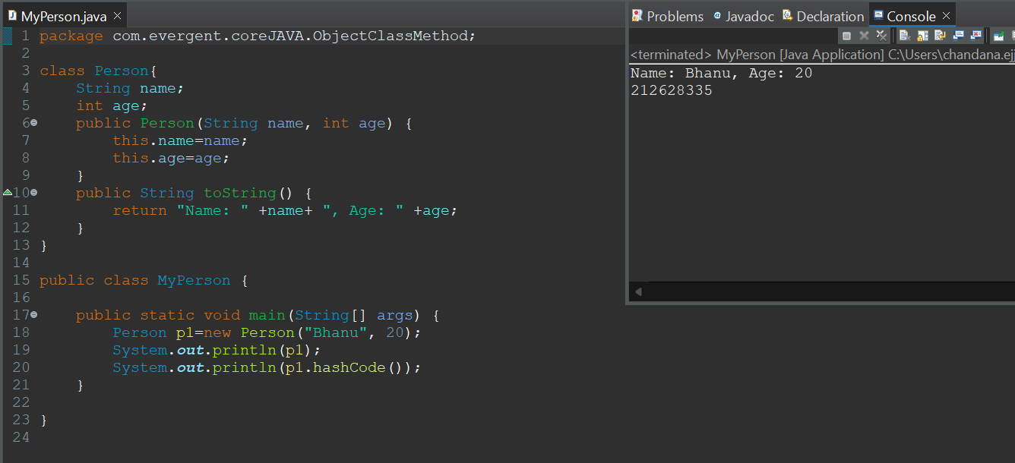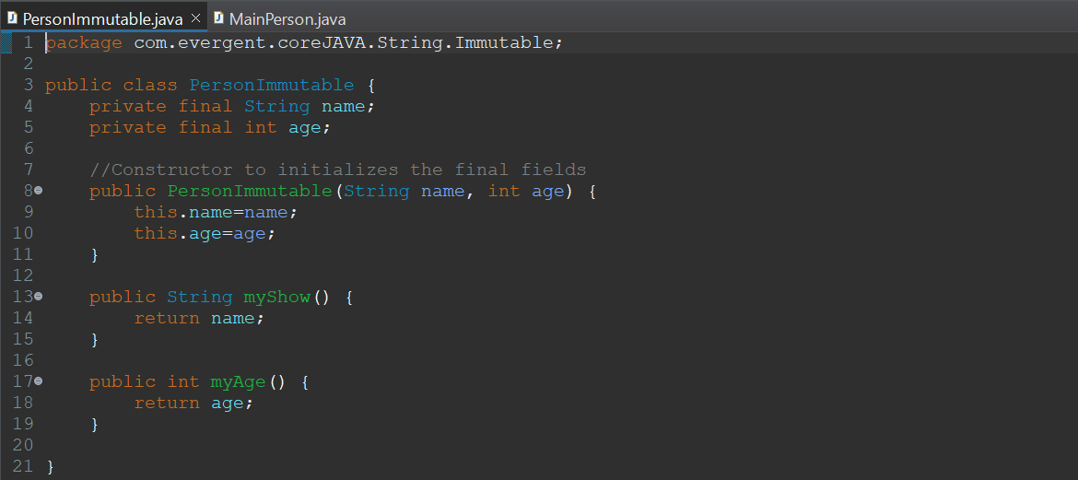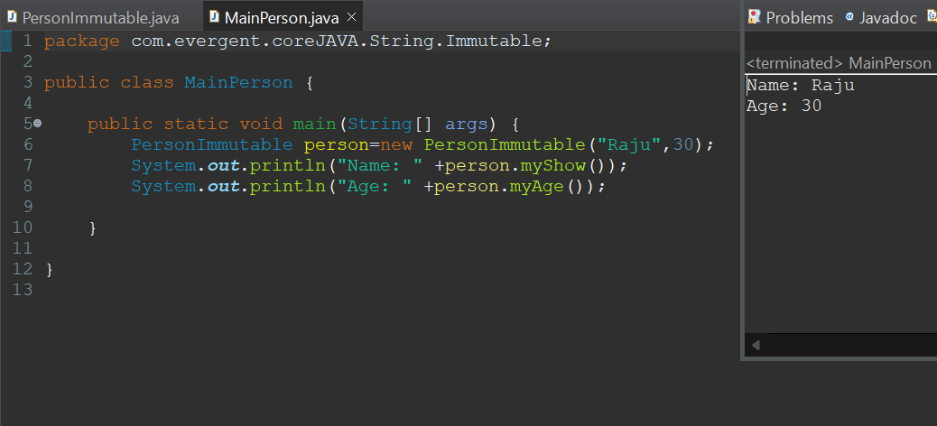

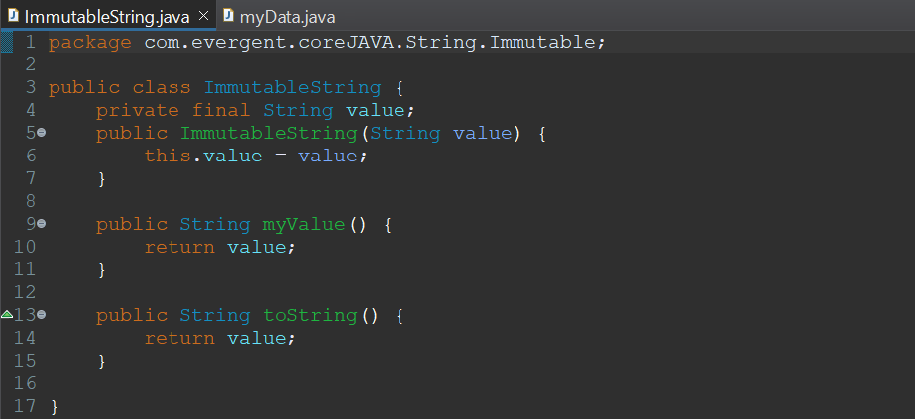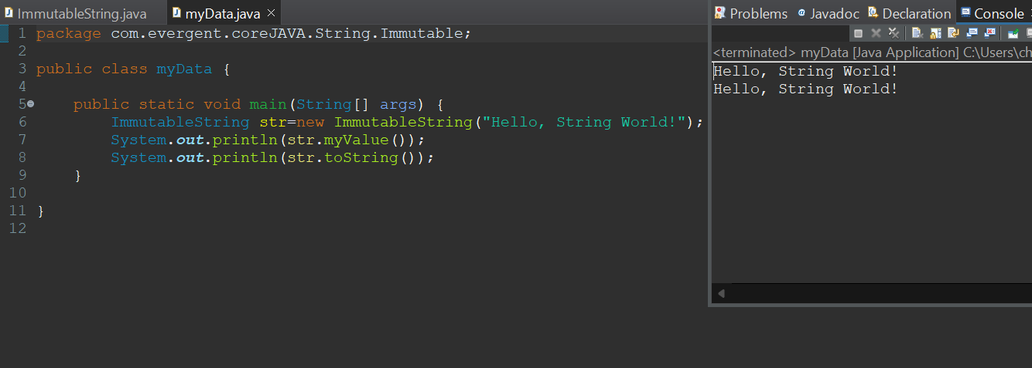

**Interfaces:**

* 1. Interface is a keyword.
  2. We can declare methods signatures only but not implementations.
  3. By default all interface methods are abstract.
  4. If any class implements interface that class should override all interface methods otherwise the class will be showing compile time error.
  5. We cannot create objects to interface, but we can create references to interface.
  6. We can declare variables inside the interface all are public static final.
  7. Java will support multiple inheritance through interface.
  8. One class can implements more than one interface.
  9. One interface can extend other interface.

#Write the program to understand the concepts of Interfaces.

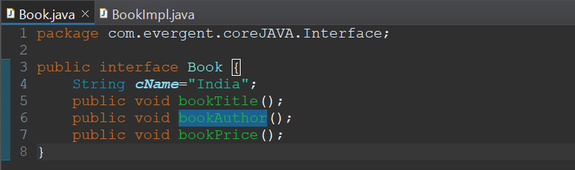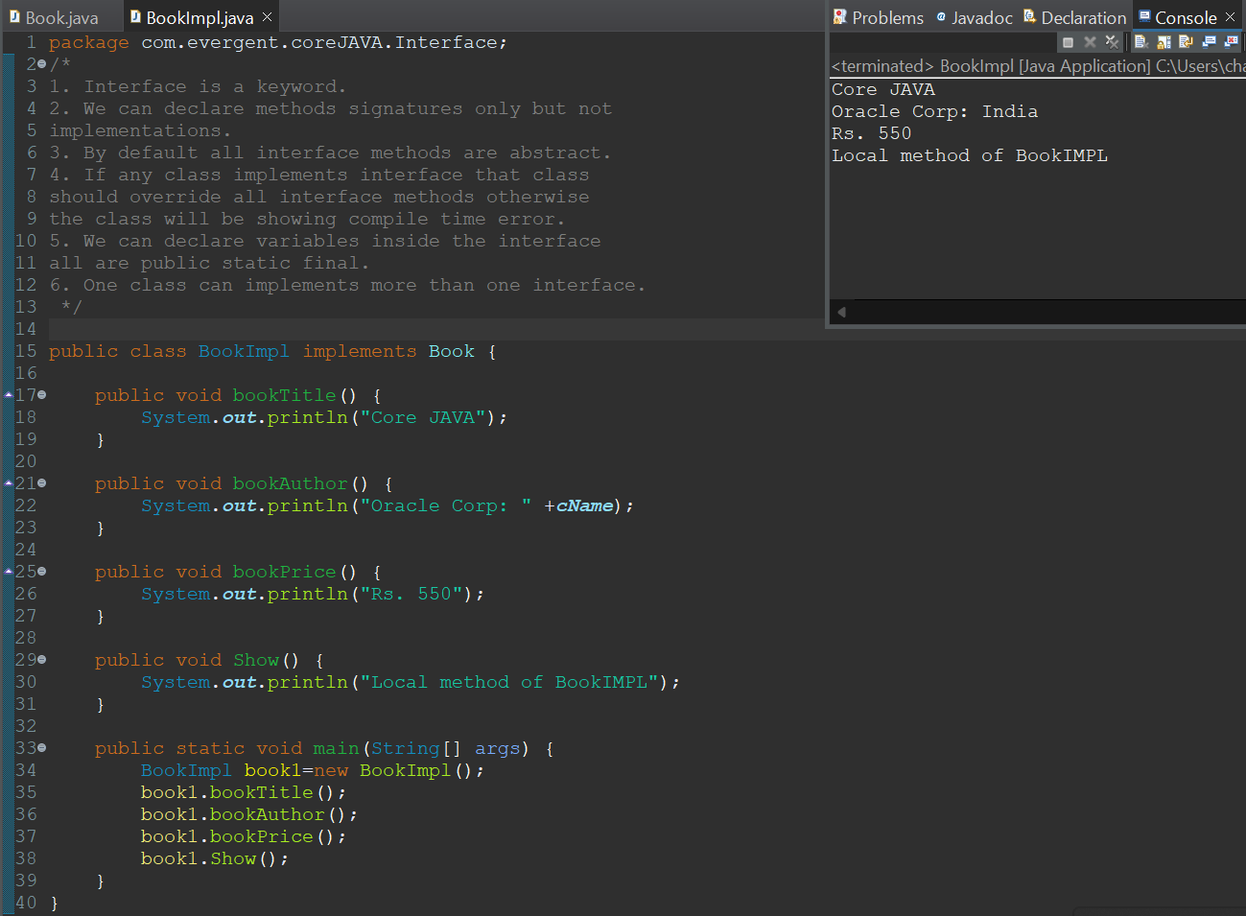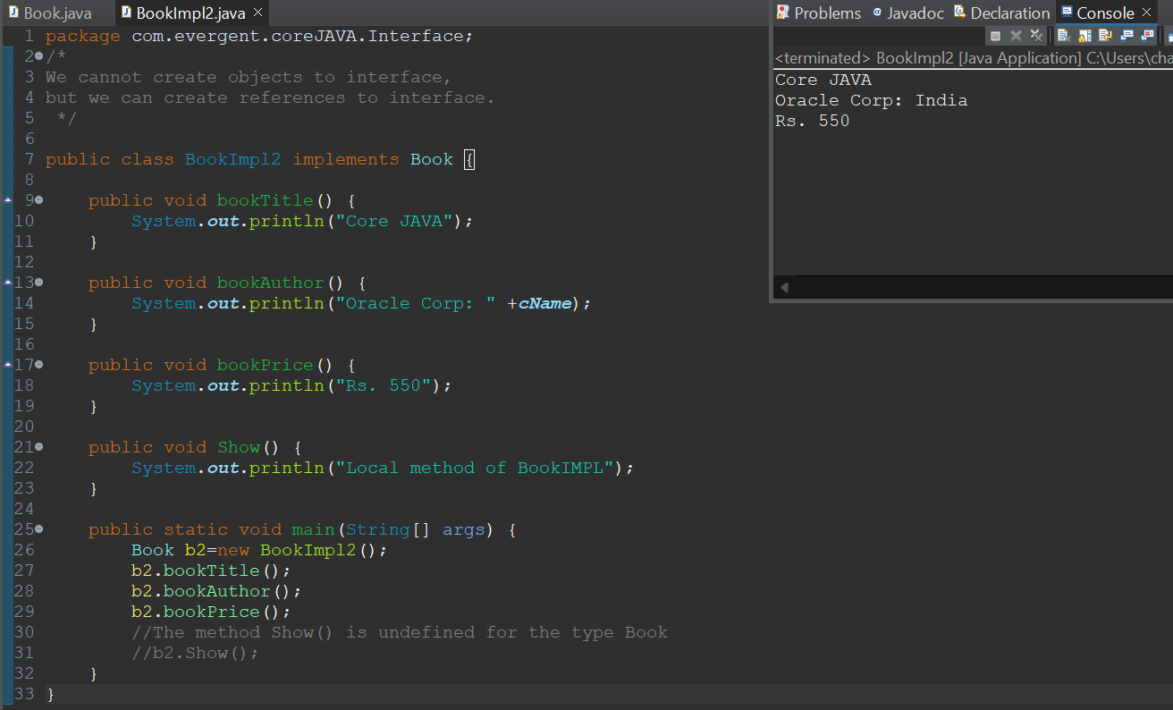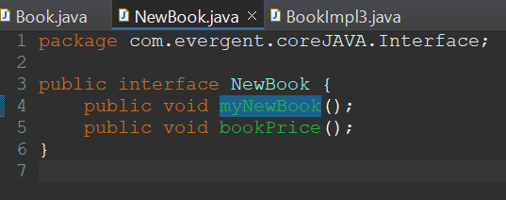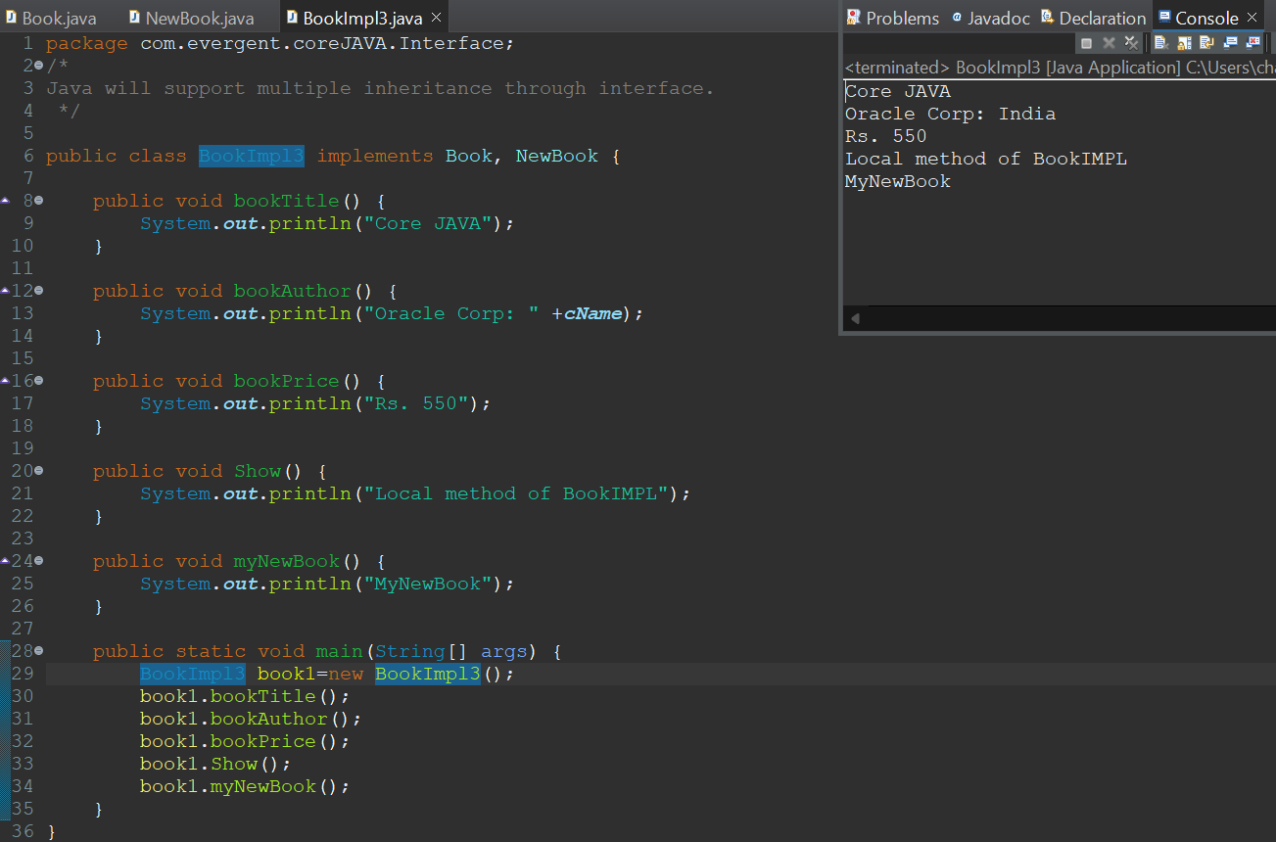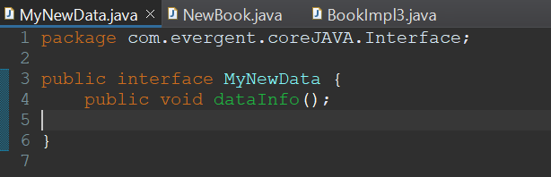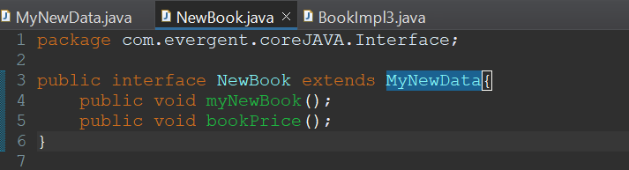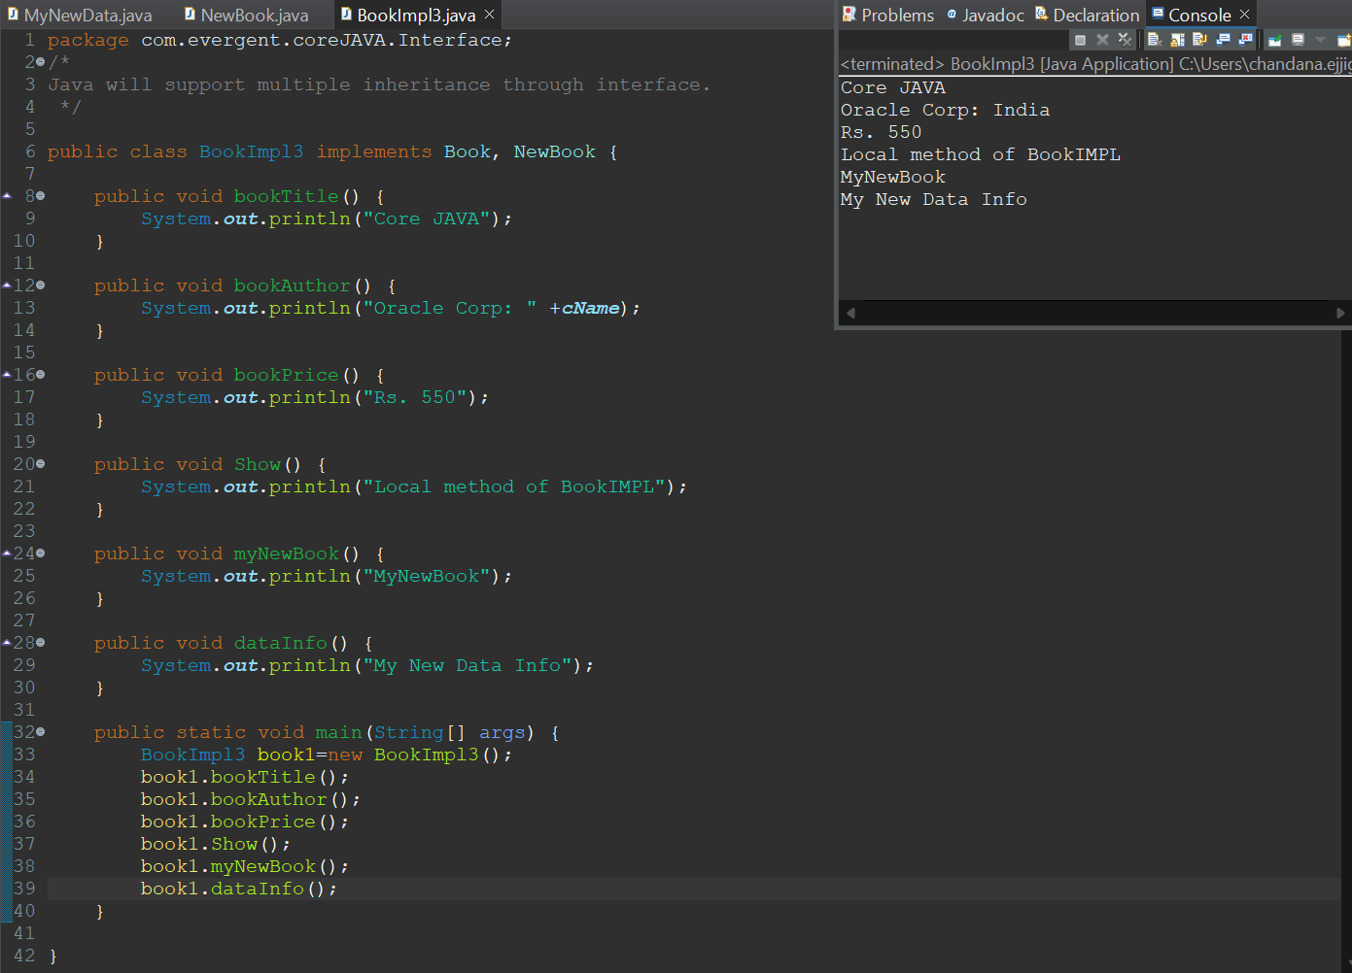

Abstract:

1. Abstract is a keyword.
2. Abstract class having abstract methods and concrete(implemented) methods.
3. If any class having one abstract method that class should be declare as abstract keyword, otherwise the class will be showing compile time error.
4. If any class extends abstract class, that class should be override all abstract all methods, otherwise the class will be showing compile time error.
5. We cannot create object to abstract class but we can create reference to abstract class.
6. We can declare abstract class with zero abstract methods.

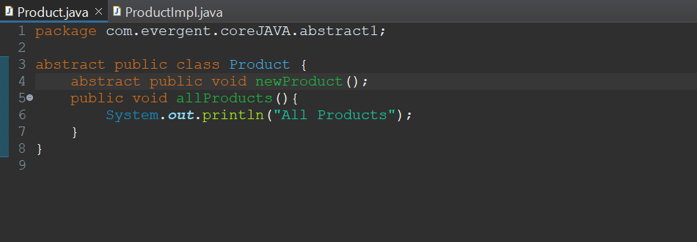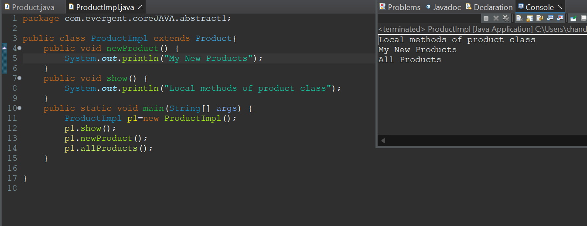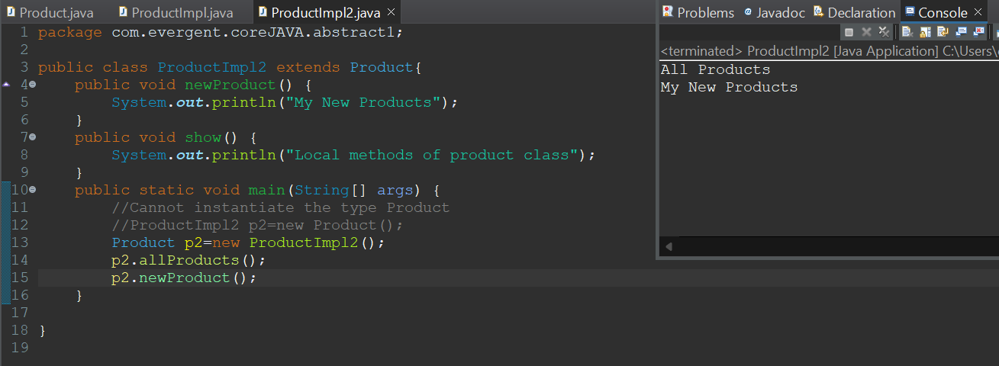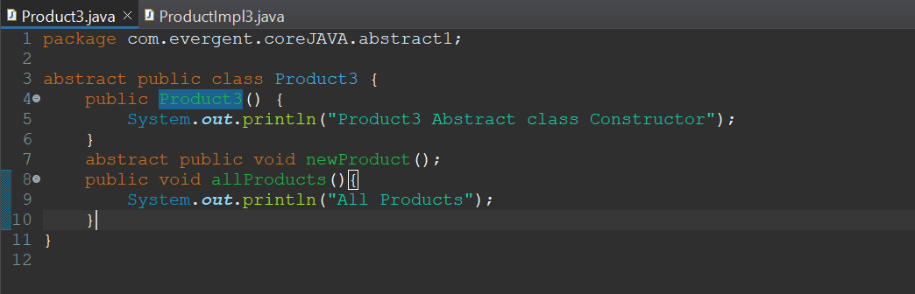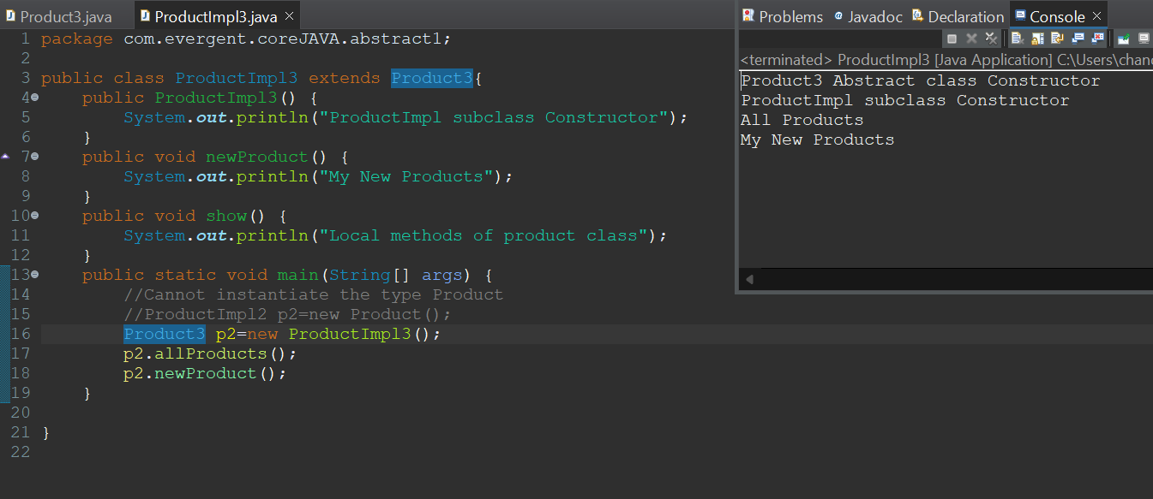

**Exception Handling:**

1. Exception Handling is a Mechanism.
2. Exceptions are inbuilt Mechanism of JAVA.
3. All Exceptions are executed during abnormal conditions only.
4. Normal flow it won’t execute any exceptions.
5. Once any exceptions are occurring in java code, then remaining lines of code is unreachable.
6. Java.lang.Throwable is super class for exception and errors.
7. There are two types of Exceptions in JAVA:
   1. Checked Exceptions
   2. Unchecked Exceptions
8. All checked Exceptions are compile time exceptions.
9. All unchecked Exceptions are run time exceptions.
10. There are 5 keywords in Exception Handling:
    1. Try
    2. Catch()
    3. Finally()
    4. Throws()
       1. Throws is a keyword.
       2. Throws an exception will be executed method by method.
       3. When we throws an exception from a method, the calling method should handle the exception.
    5. Throw()
       1. Throw is a keyword.
       2. Throw is for runtime exceptions and will call predefined exceptions or user defined exceptions.
11. Try is for business logic.
12. Catch for handling exceptions.
13. Finally is a block, if exceptions occurs or not finally block will be executed.
14. Throws an exception will be executed method by method
15. Throw is for runtime exceptions and will call predefined exceptions or user defined exceptions.
16. Try followed by either catch block or finally block.
17. We should follow exceptions hierarchical.
18. We can create our own (User Defined) exceptions.
19. Our own exceptions extends exception or runtime exception.
20. All Exceptions classes are in to java.lang package.
21. If there are 2 exceptions in try, developer should handle 1st exception after that 2nd exception will be handled.
22. Developer can’t handle errors.
23. Handling Multiple exceptions with throws
24. Handling Multiple exceptions with multi-catch
25. In Java, nested try-catch block is a try-catch block within another try-catch block.

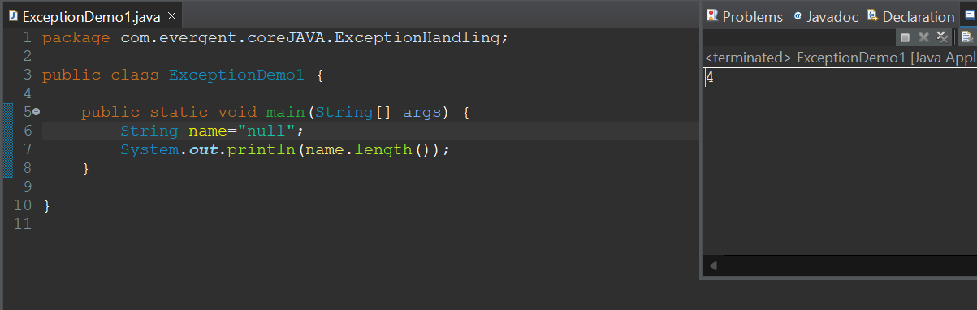

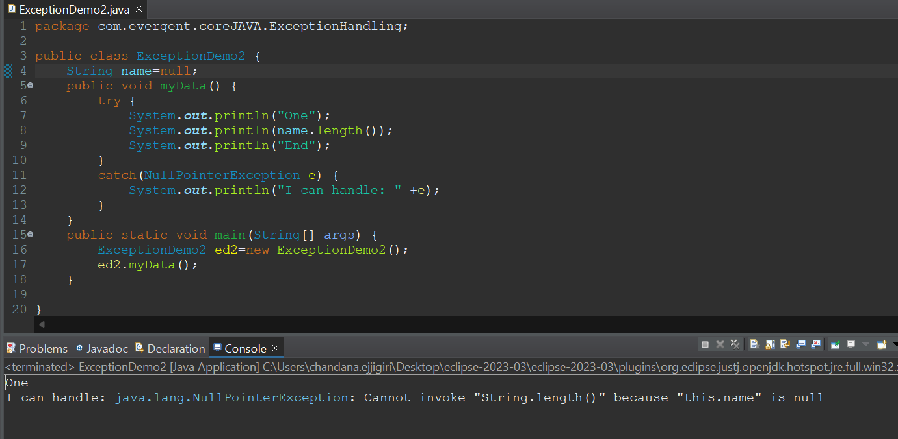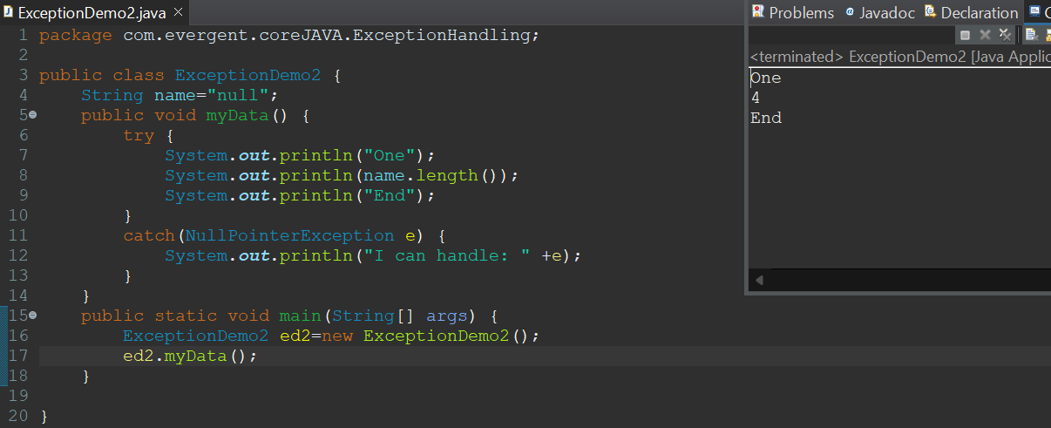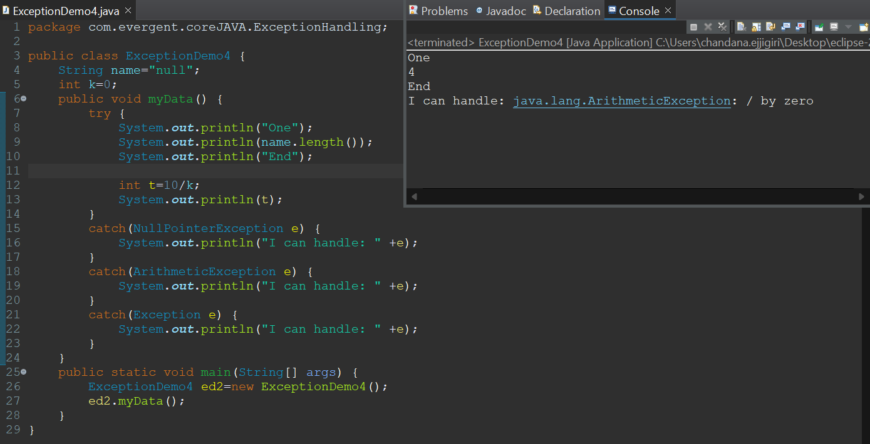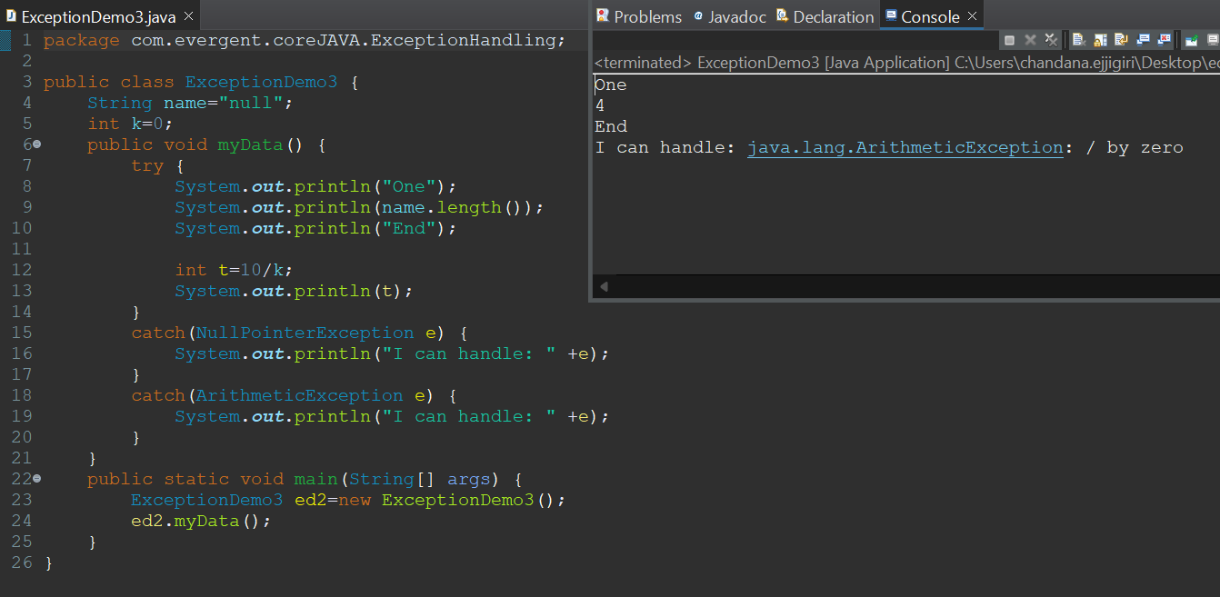

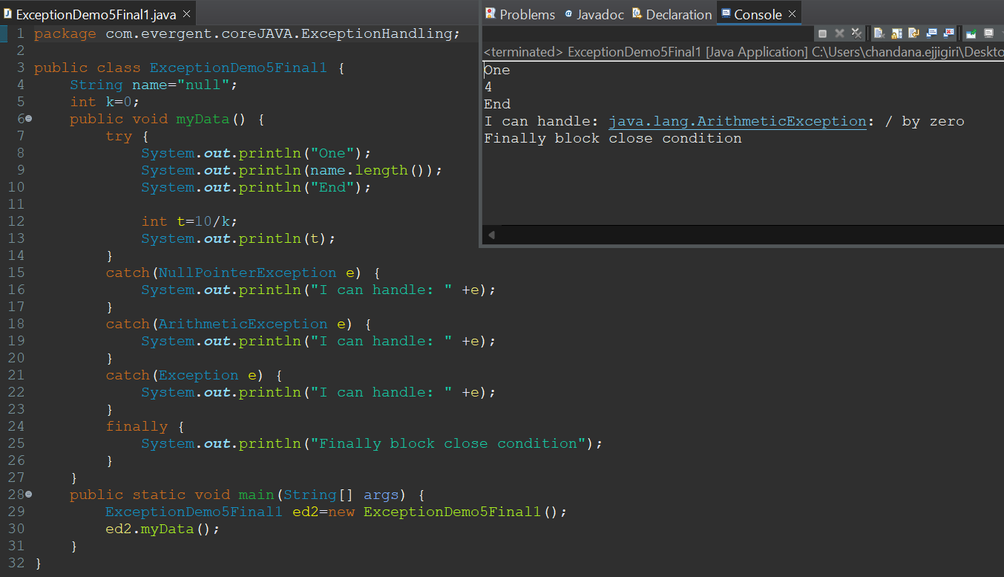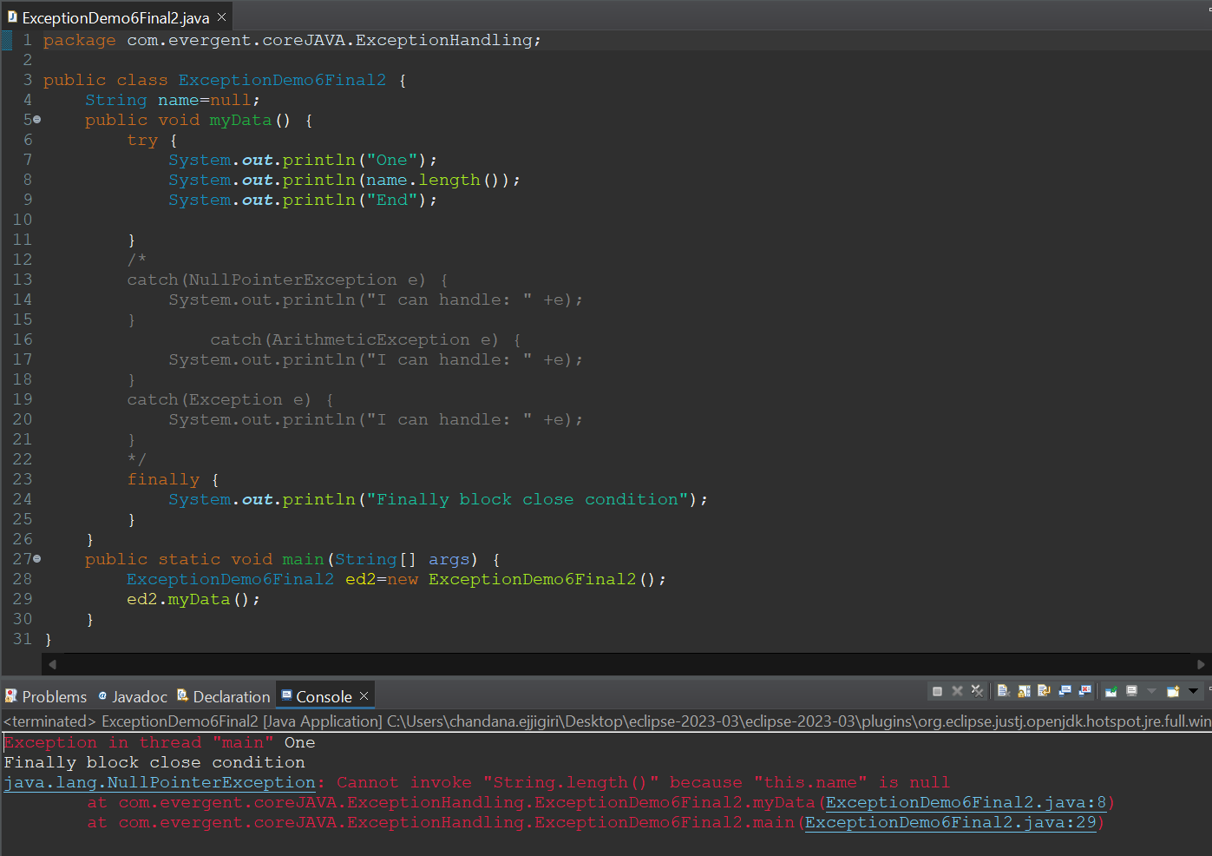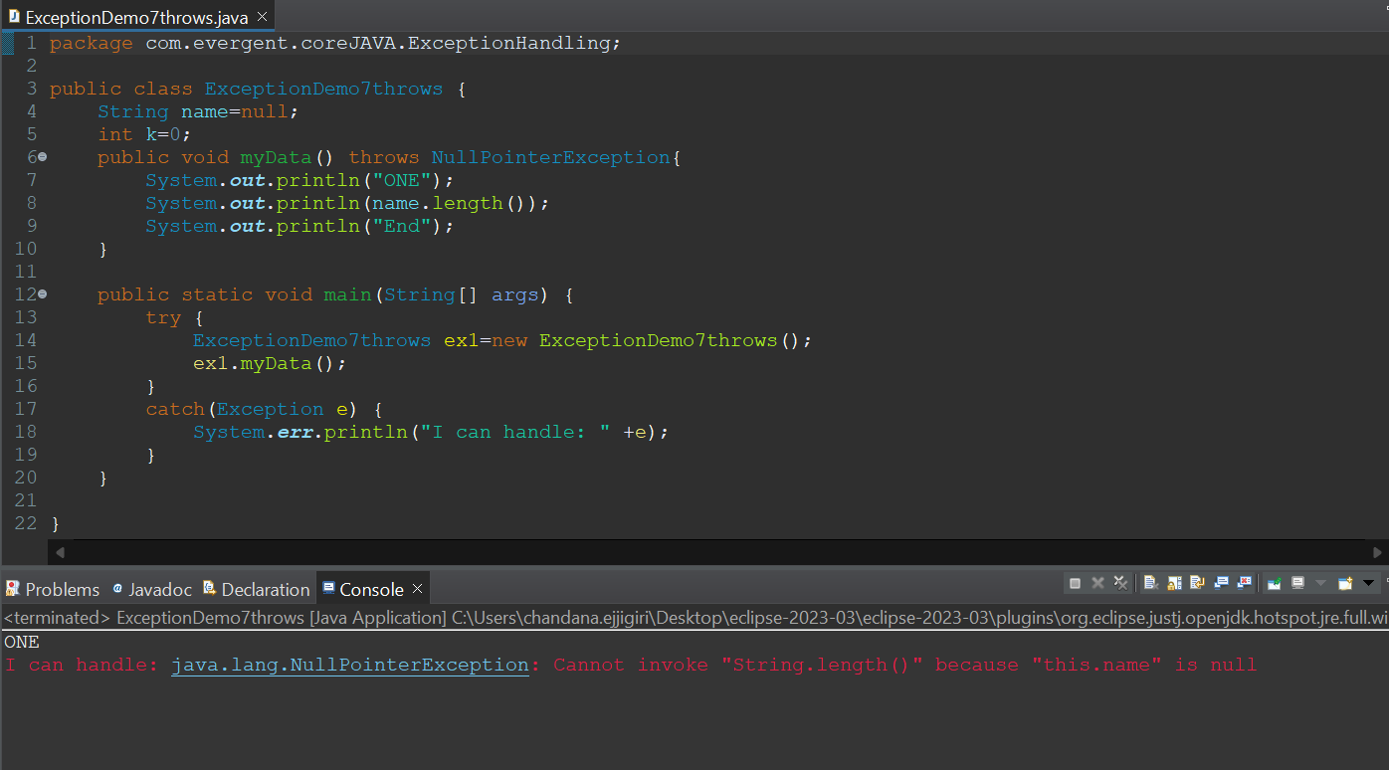

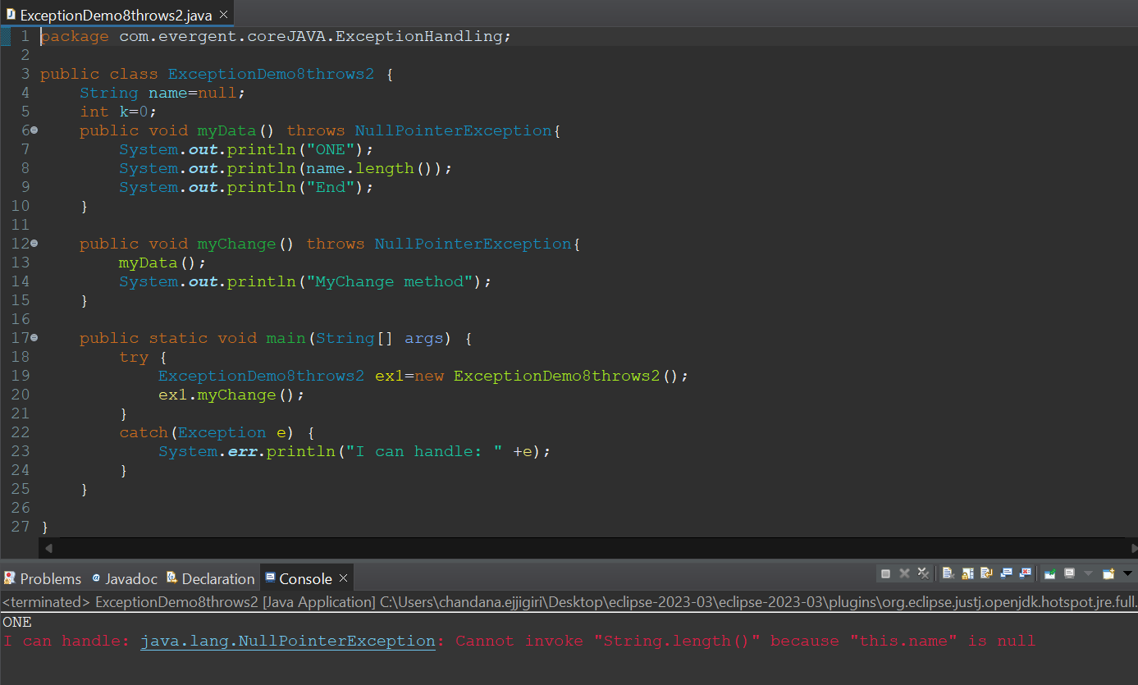

Completed execution of Programs on Exception Handling using keyword Throw.

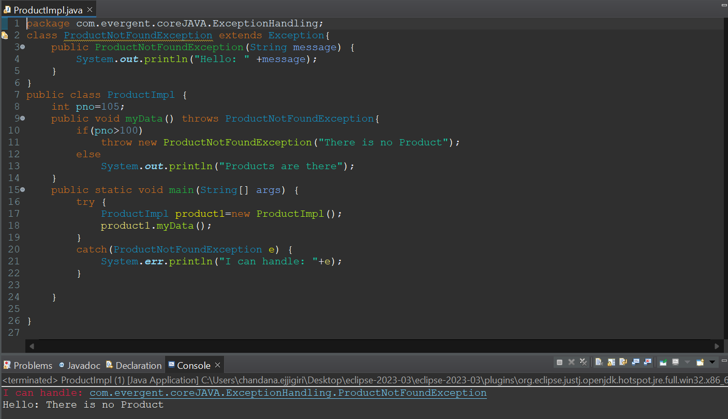

#userdefined

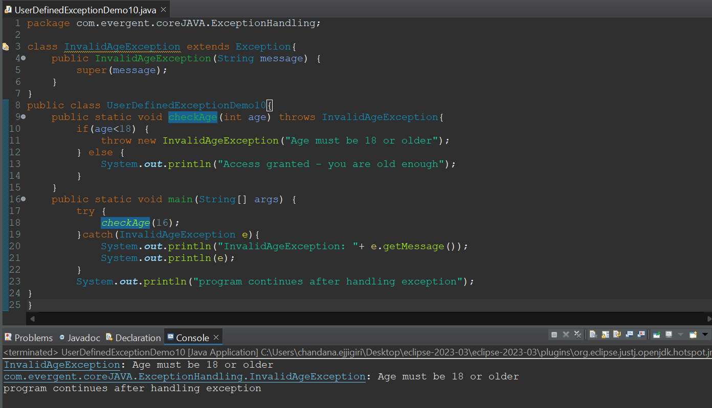

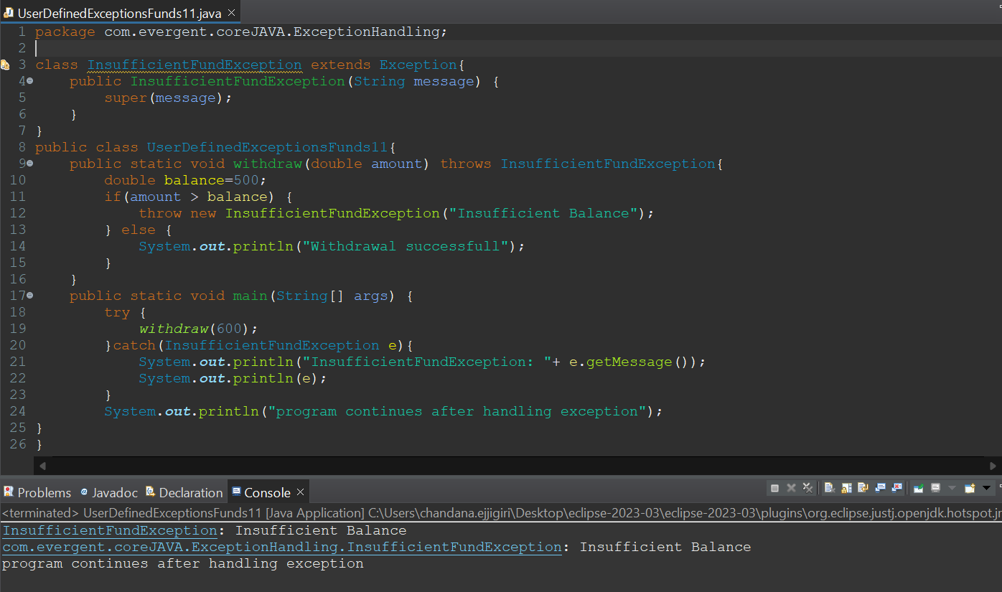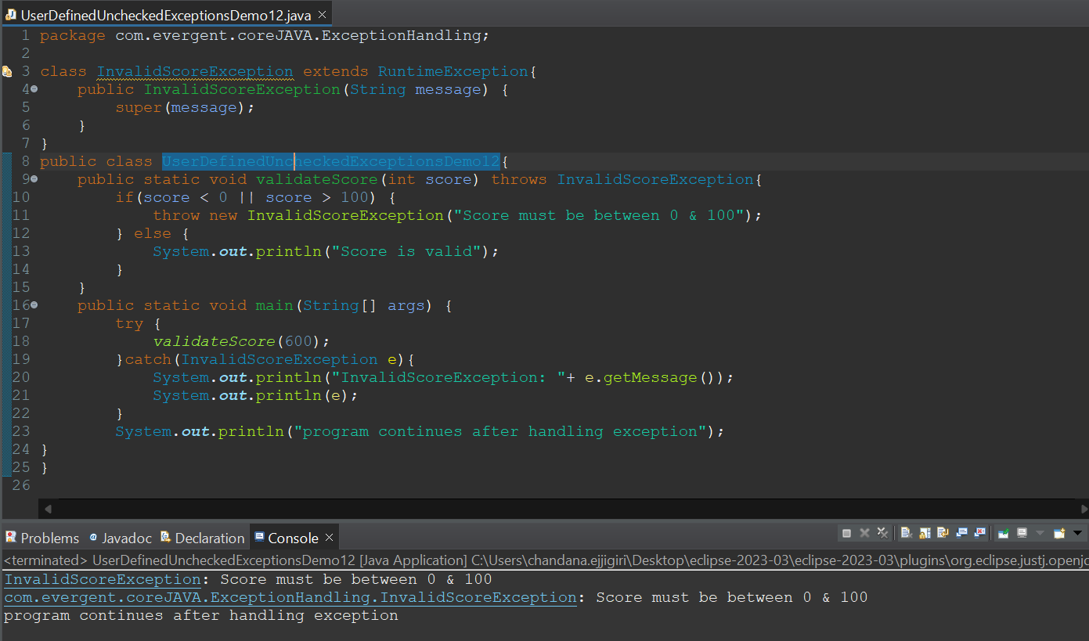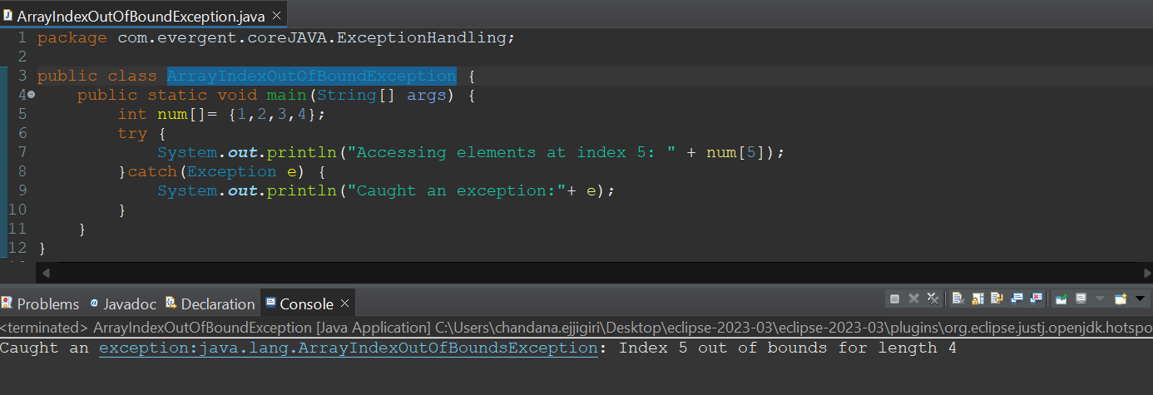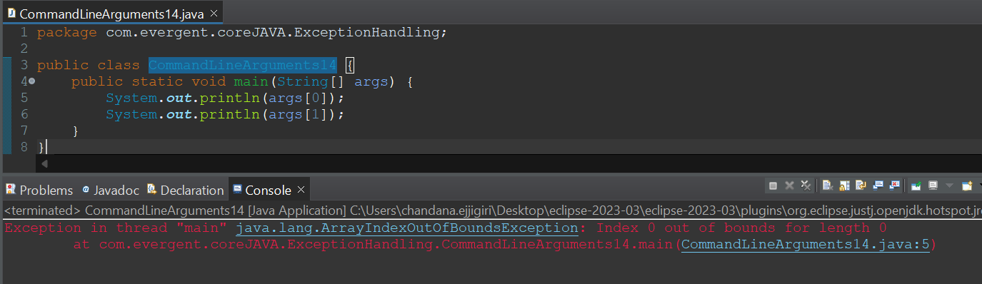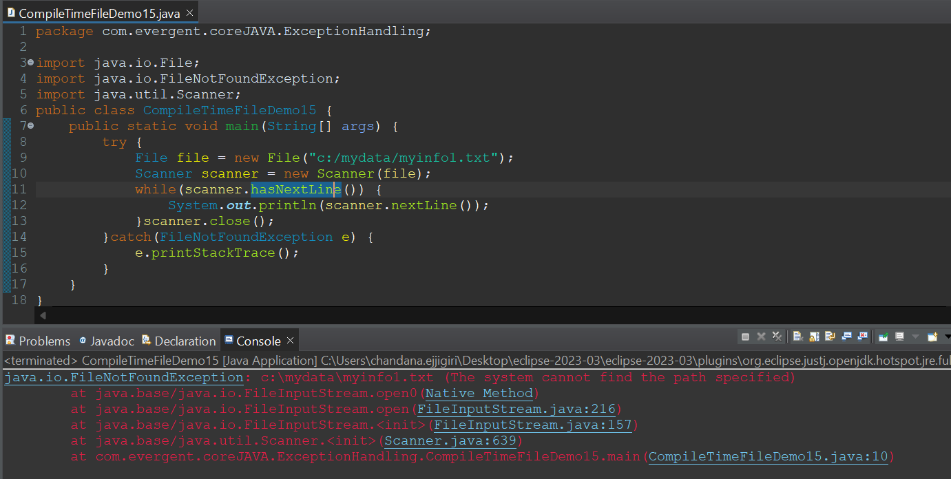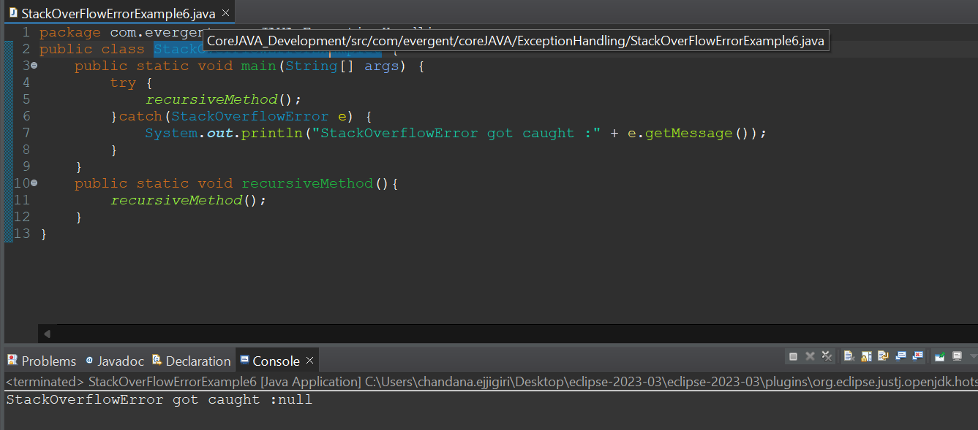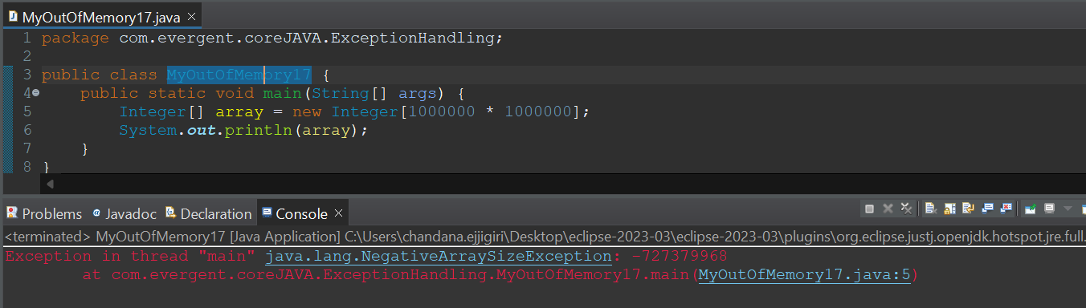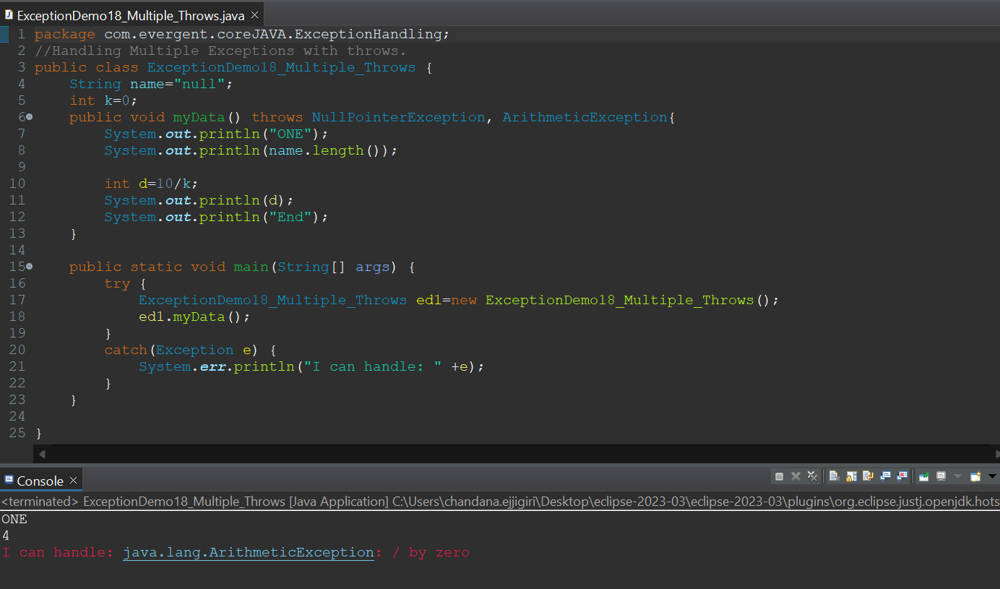

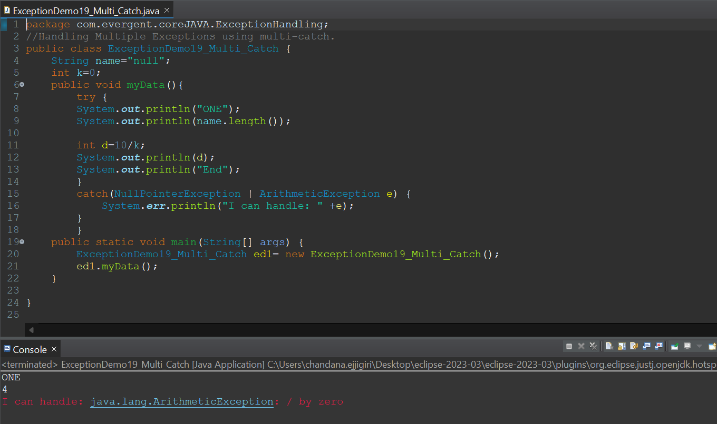

**Wrapper class.**

1. Wrapper class in jdk 1.44 version.
2. Wrapper class have auto boxing and unboxing techniques.
3. Autoboxing basically is storing the primitive datatype value in the object.
4. Unboxing is retrieving values from object to datatype.

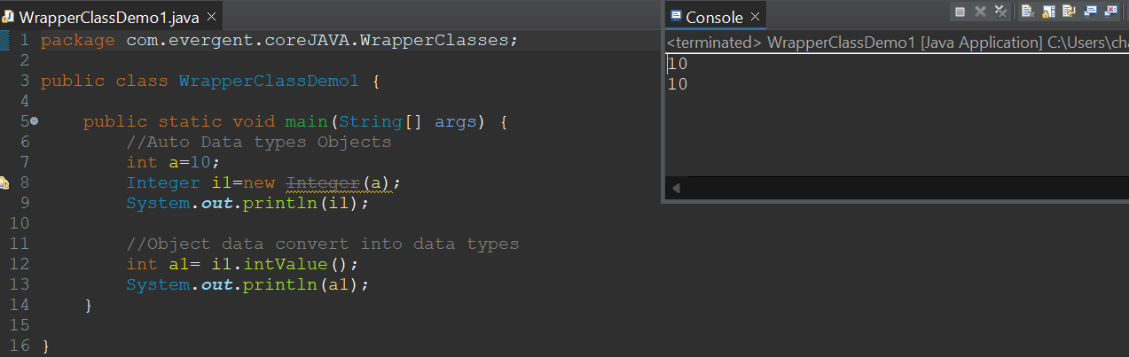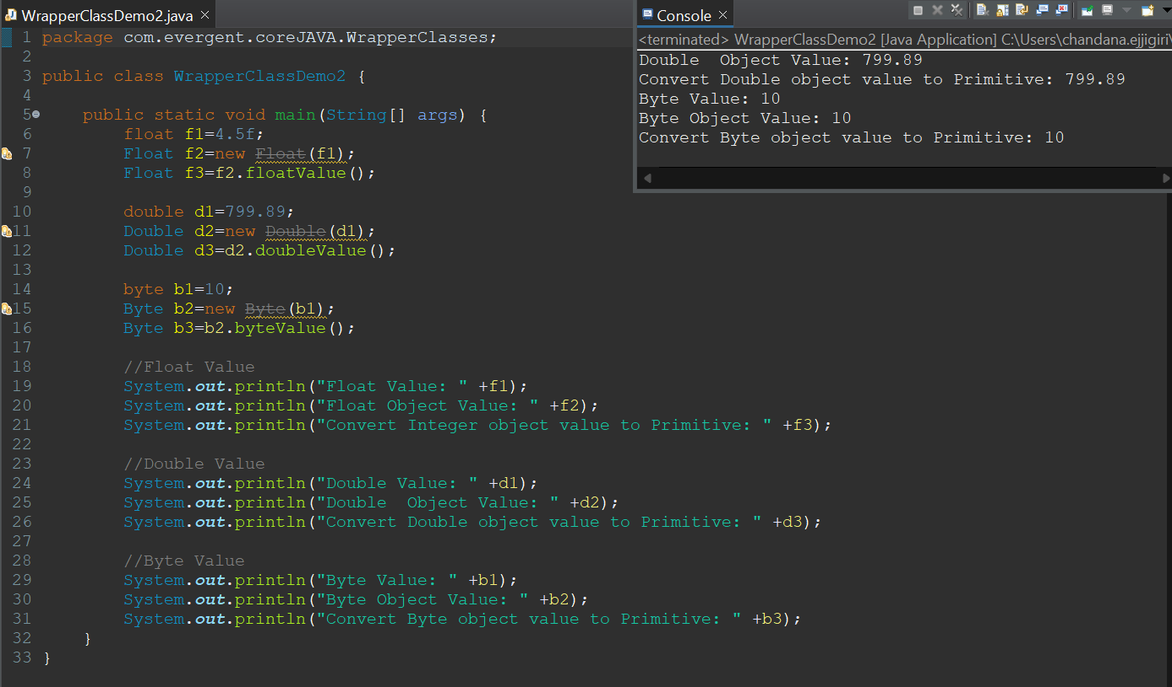

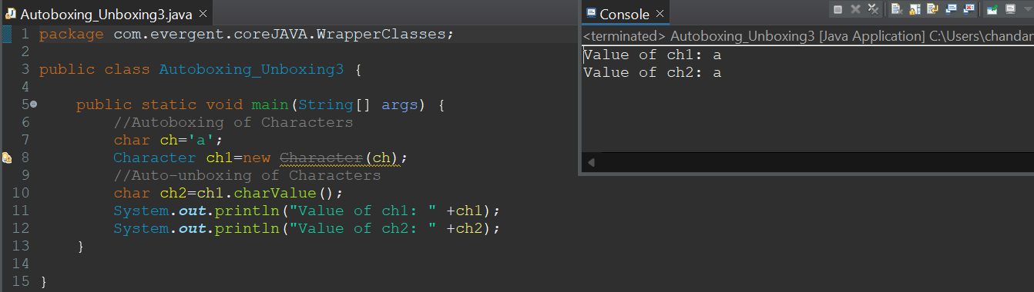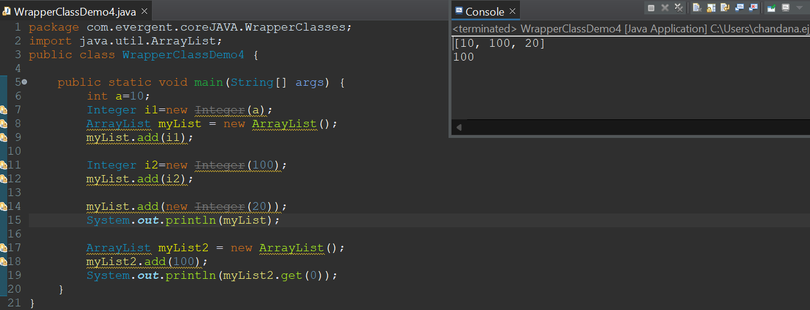

**Java Beans :**

1. Java Bean is a Mechanism.
2. Java Bean is light weight.
3. All attributes are private,get/set methods are public implements java.io.Serializable interface.
4. We can achieve tightly Encapsulation through java beans.

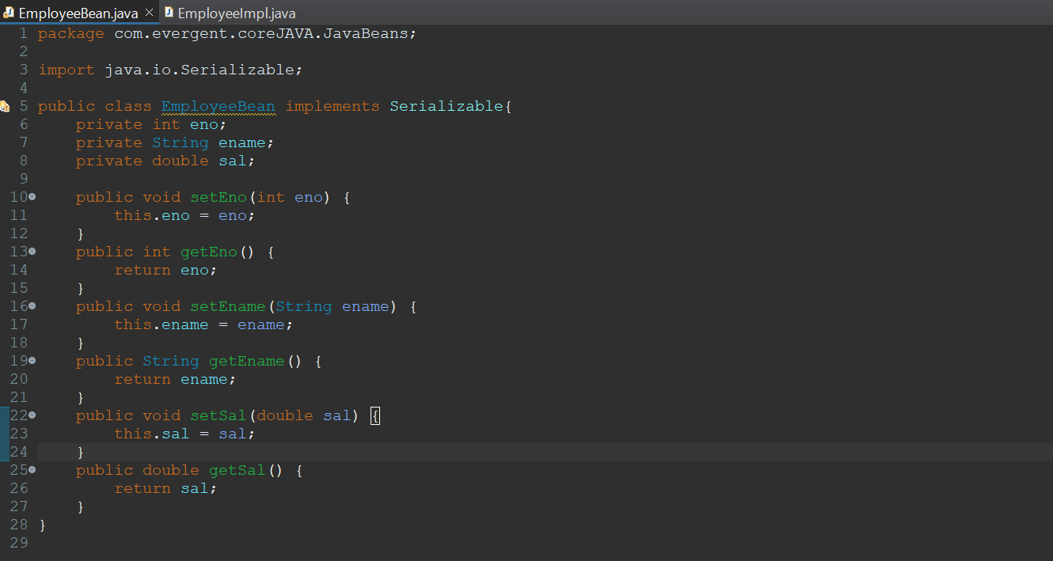

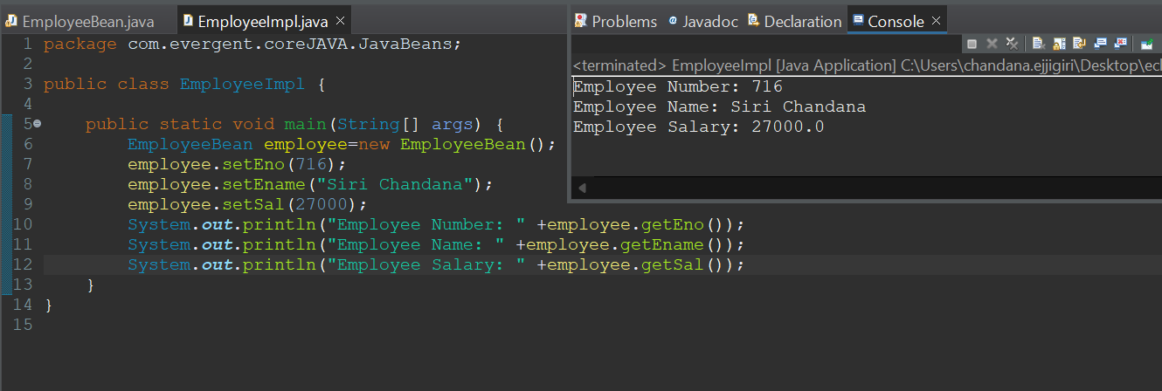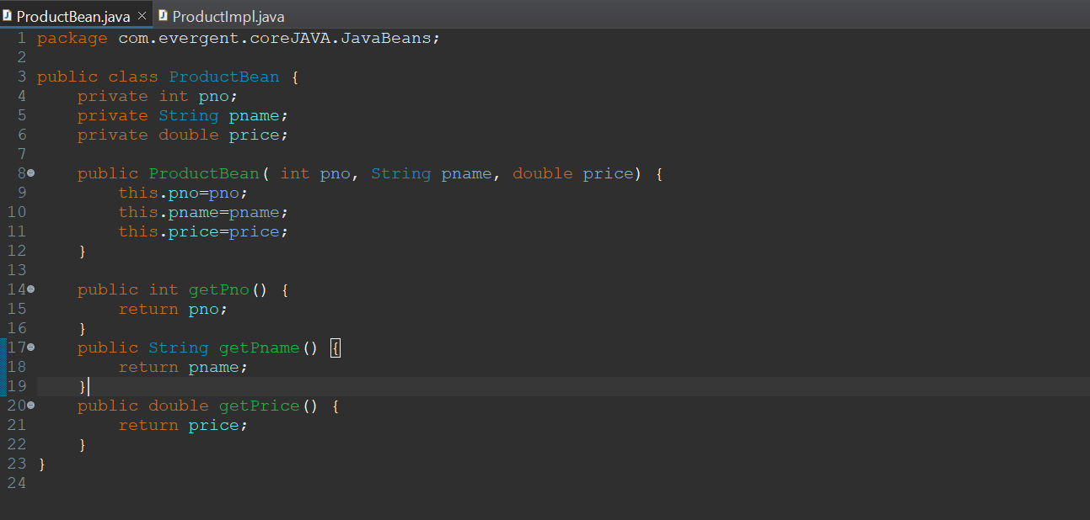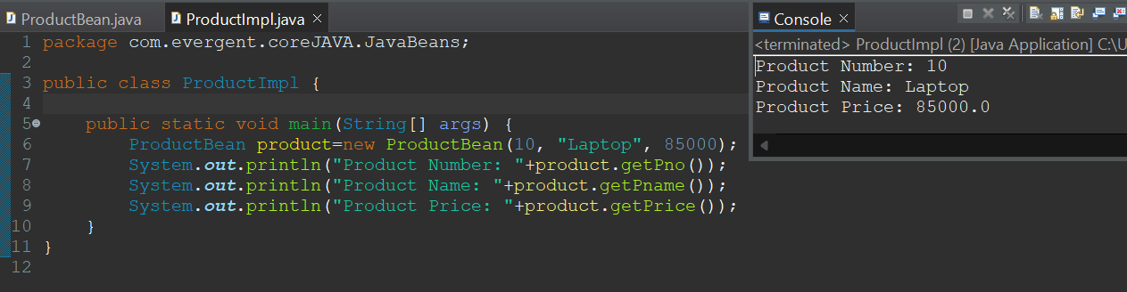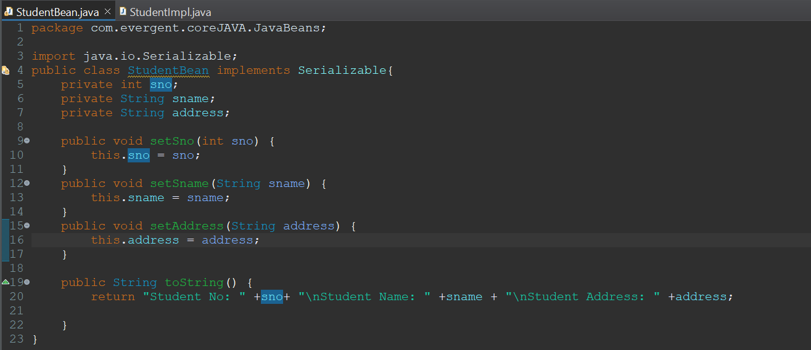

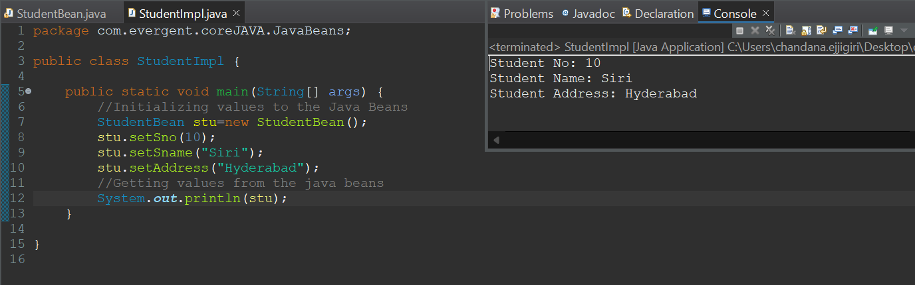

**Variable Lifetime:** Lifetime refers to the duration during which a variable exists in memory.

1. Local Variables: stored in the stack memory.
2. Instance variables: heap memory.
3. Static variables: stored in method area (a part of heap memory that is shared among all the threads )

**Casting:**

**Widening Conversion Hierarchy:**

byte -> short -> int -> long -> float -> double

**Explicit Type Casting:**

1. conversion of larger datatype to smaller datatype
2. Explicit type casting, also known as narrowing conversion.

**Narrowing conversion Hierarchy:**

double -> float -> long -> int -> short -> byte

**Implicit (Automatic) Type Conversion:**

1. conversion of smaller datatype to larger datatype
2. Implicit type conversion is also known as widening conversion.

Fall-Through behaviour in switch case.

**Multi-Threading:**

1. Multiple threads running simultaneously reducing the CPU ideal time.
2. Thread is light weight and object is heavy weight.
3. Life cycle of a thread. All the stages in life-cycle of a thread.
4. We can write threads in two ways:
   1. By extending the thread class.
   2. By Implementing Runnable Interface.
5. Some methods in the threads are:
6. Start(), Run(), isAlive(), yield(), join(), suspend(), sleep(), wait(), resume(), notify(), notifyAll(), stop().

